**CST8912 – Cloud Solution Architecture**

**Graded Lab Activity #10**

1. Evaluate the security and data privacy implications of various cloud solutions.

* Explore different encryption tools and technologies to protect the privacy and integrity of client’s data
* Describe authentication and identity management mechanisms to protect user’s information
* Identify best practices and industry standards to adopt a secure cloud to protect client information
* Evaluate the levels of security for each cloud service model (IaaS, PaaS, SaaS)
* Underline cloud security challenges and steps to maximize reliability and resiliency of application services

**Introduction:**

Azure Logic Apps is the PaaS (Platform as a Service) offering from Microsoft Azure. Logic Apps helps us to define workflows and build powerful solutions with the help of connectors, triggers, and actions.  
  
Azure Logic Apps is a cloud platform where you can create and run automated workflows with little to no code. By using the visual designer and selecting from prebuilt operations, you can quickly build a workflow that integrates and manages your apps, data, services, and systems.

Few examples where logic apps can be used:

1. Schedule and send email notifications using Office 365 when a specific event happens, for example, a new file is uploaded.
2. Route and process customer orders across on-premises systems and cloud services.
3. Move uploaded files from an SFTP or FTP server to Azure Storage.
4. Monitor tweets, analyze the sentiment, and create alerts or tasks for items that need review.

**Purpose of this lab:**

Task 1: how you can alert users based on the data present/updated in your SQL Database.

Task 2: how to alert users when file gets uploaded/deleted in blob storage

Task3 : Monitoring workflows in azure monitor

Task 4: Clean resources and record all the steps with screenshots in the lab report.

Problem statement: I have a storage account in Azure . In the container we are storing various data files . The files are stored in tree hierarchy of folders ( Parent-> year -> month -> day).Each day new files get uploaded to the specific day folder . If the file for that specific day is not uploaded I would like to drop email notification

Task 1:

1. Create logic app (choose consumption based plan) and sql database instance in Canada central region

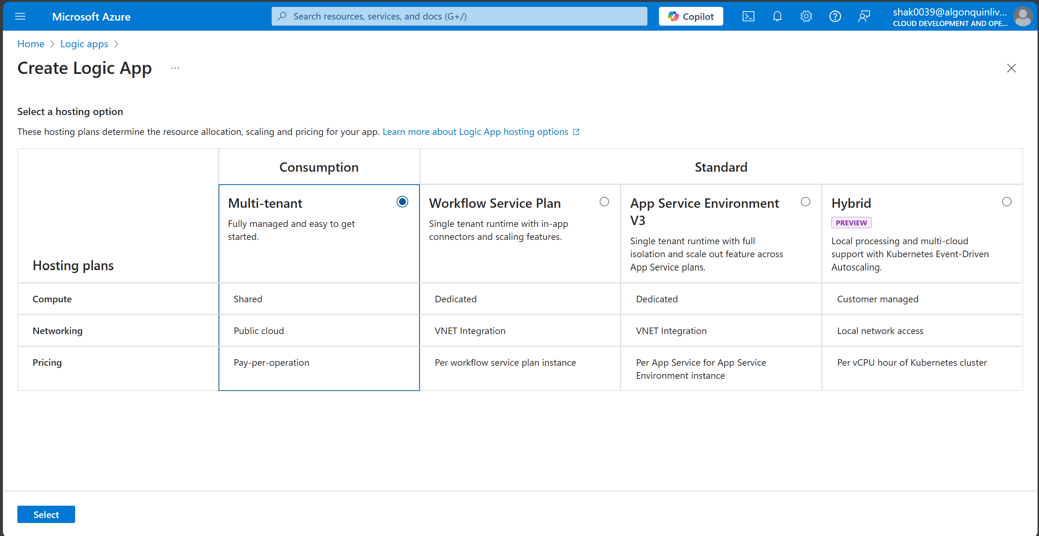

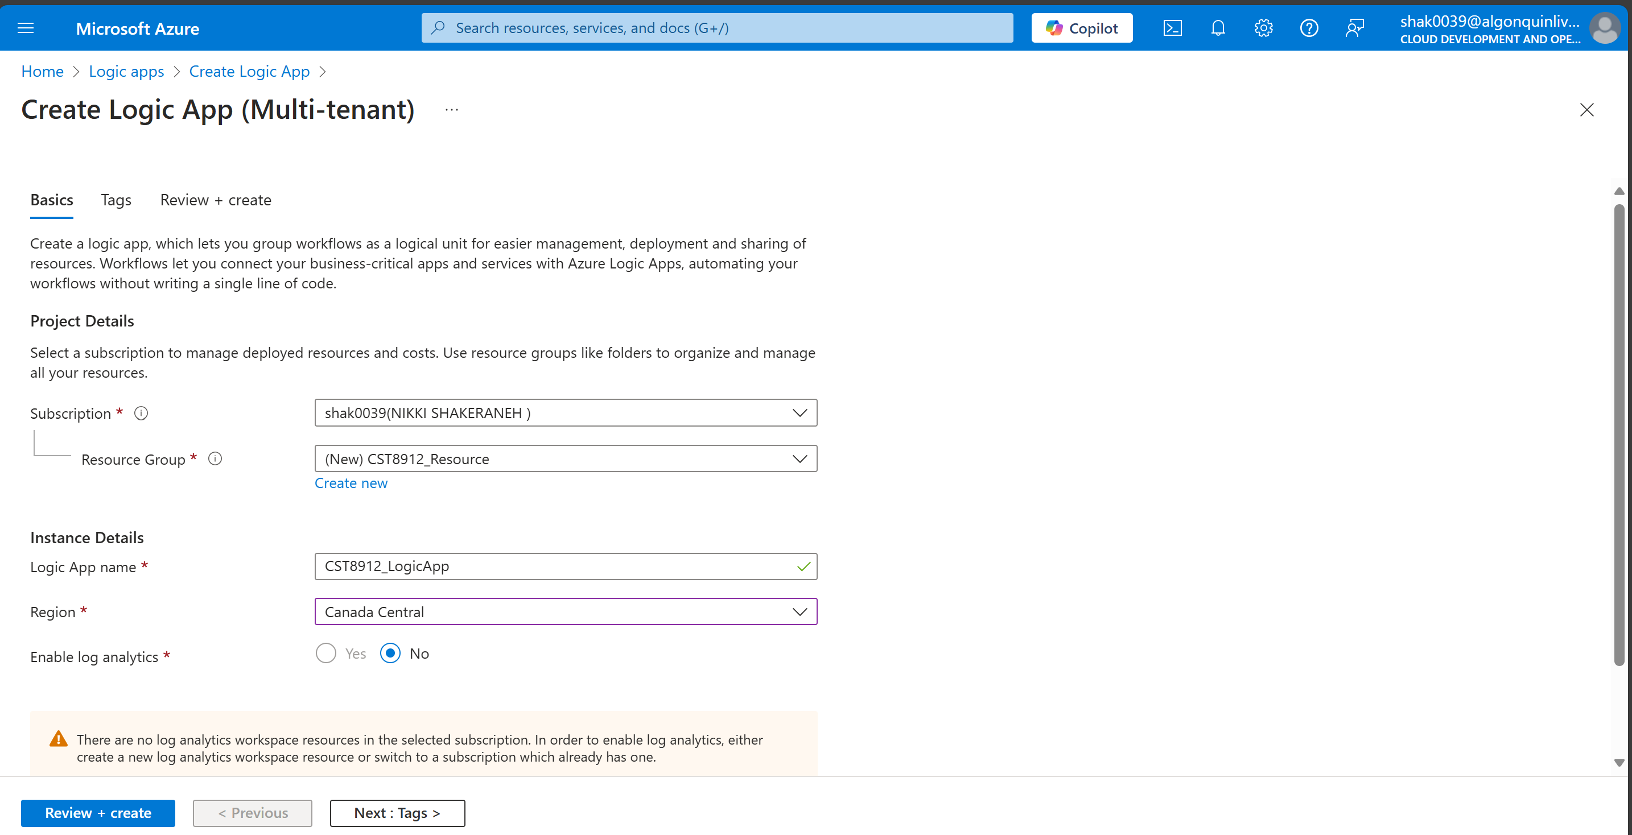

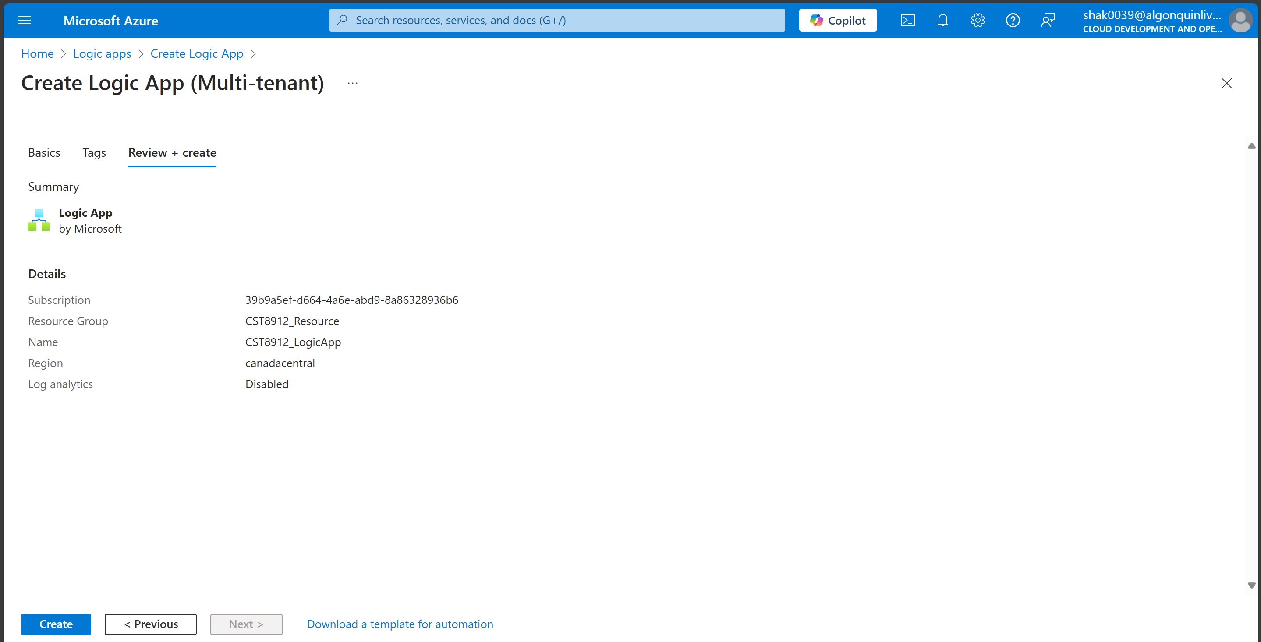

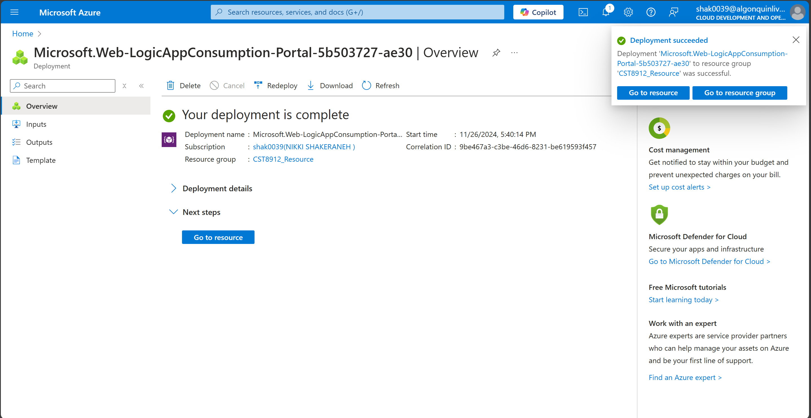

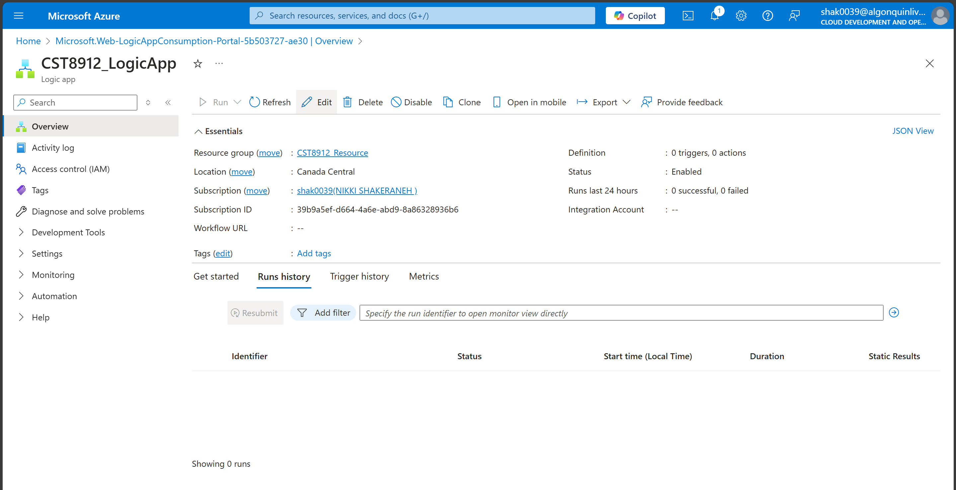

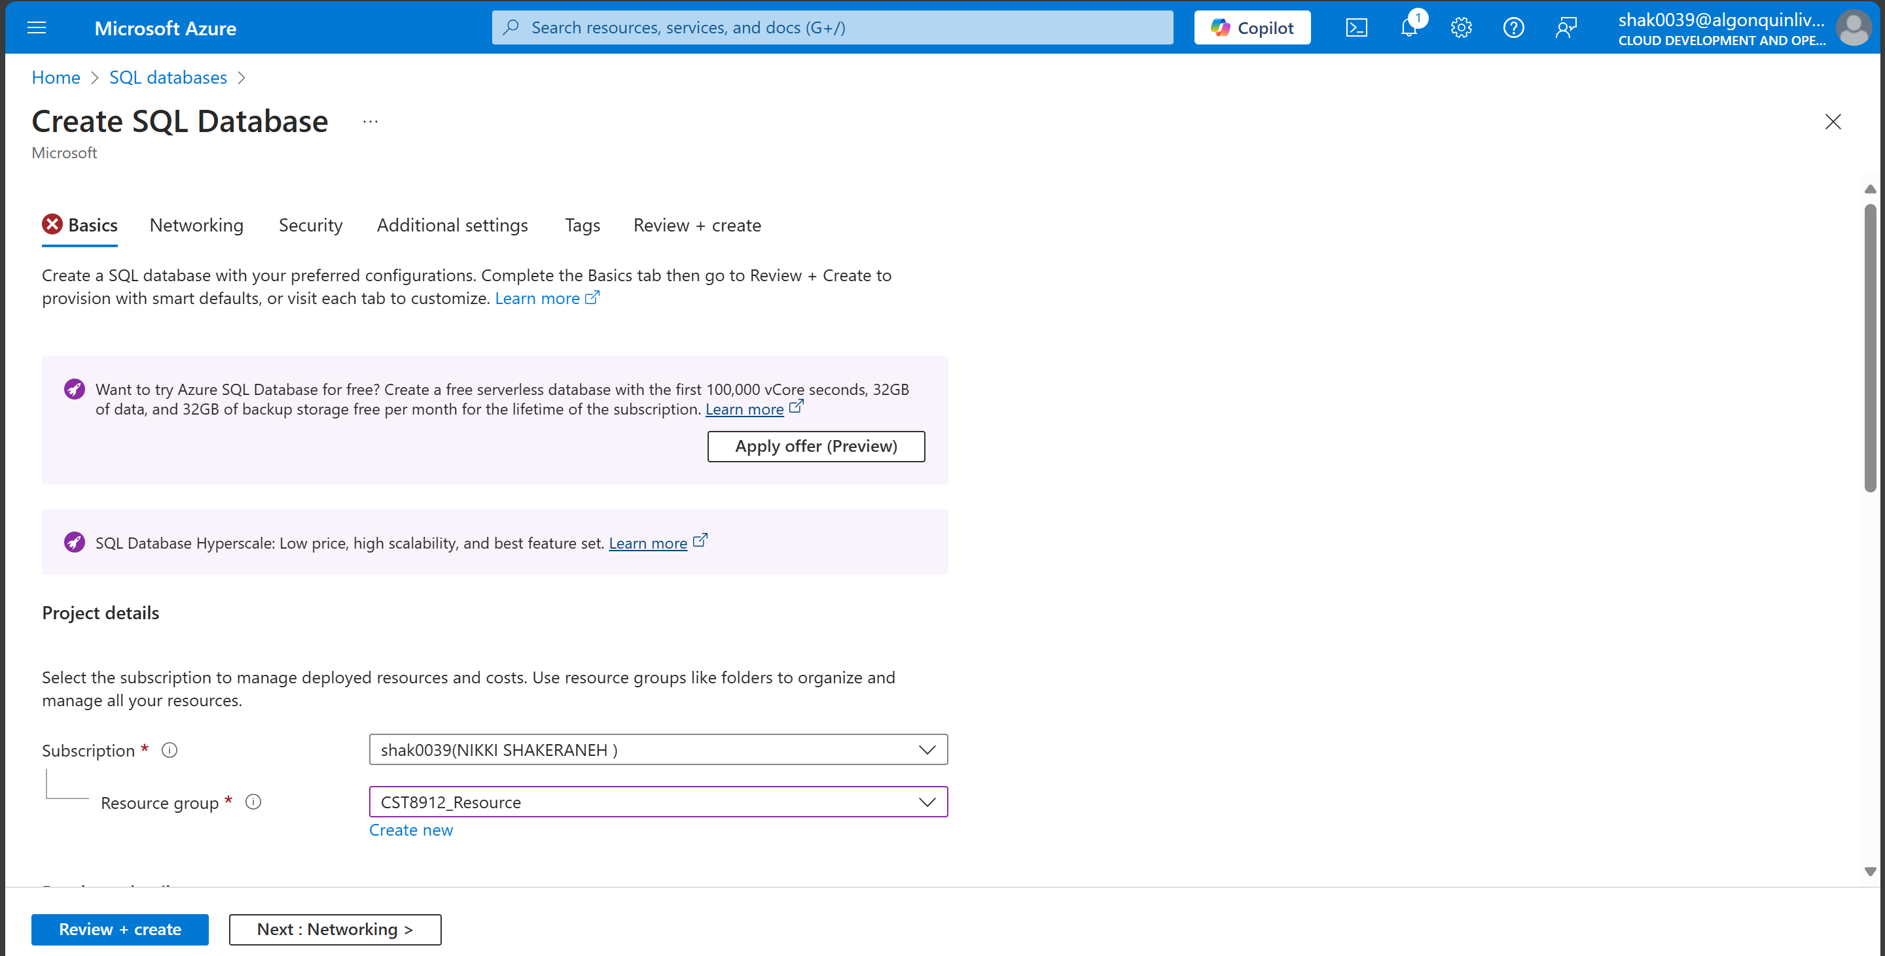

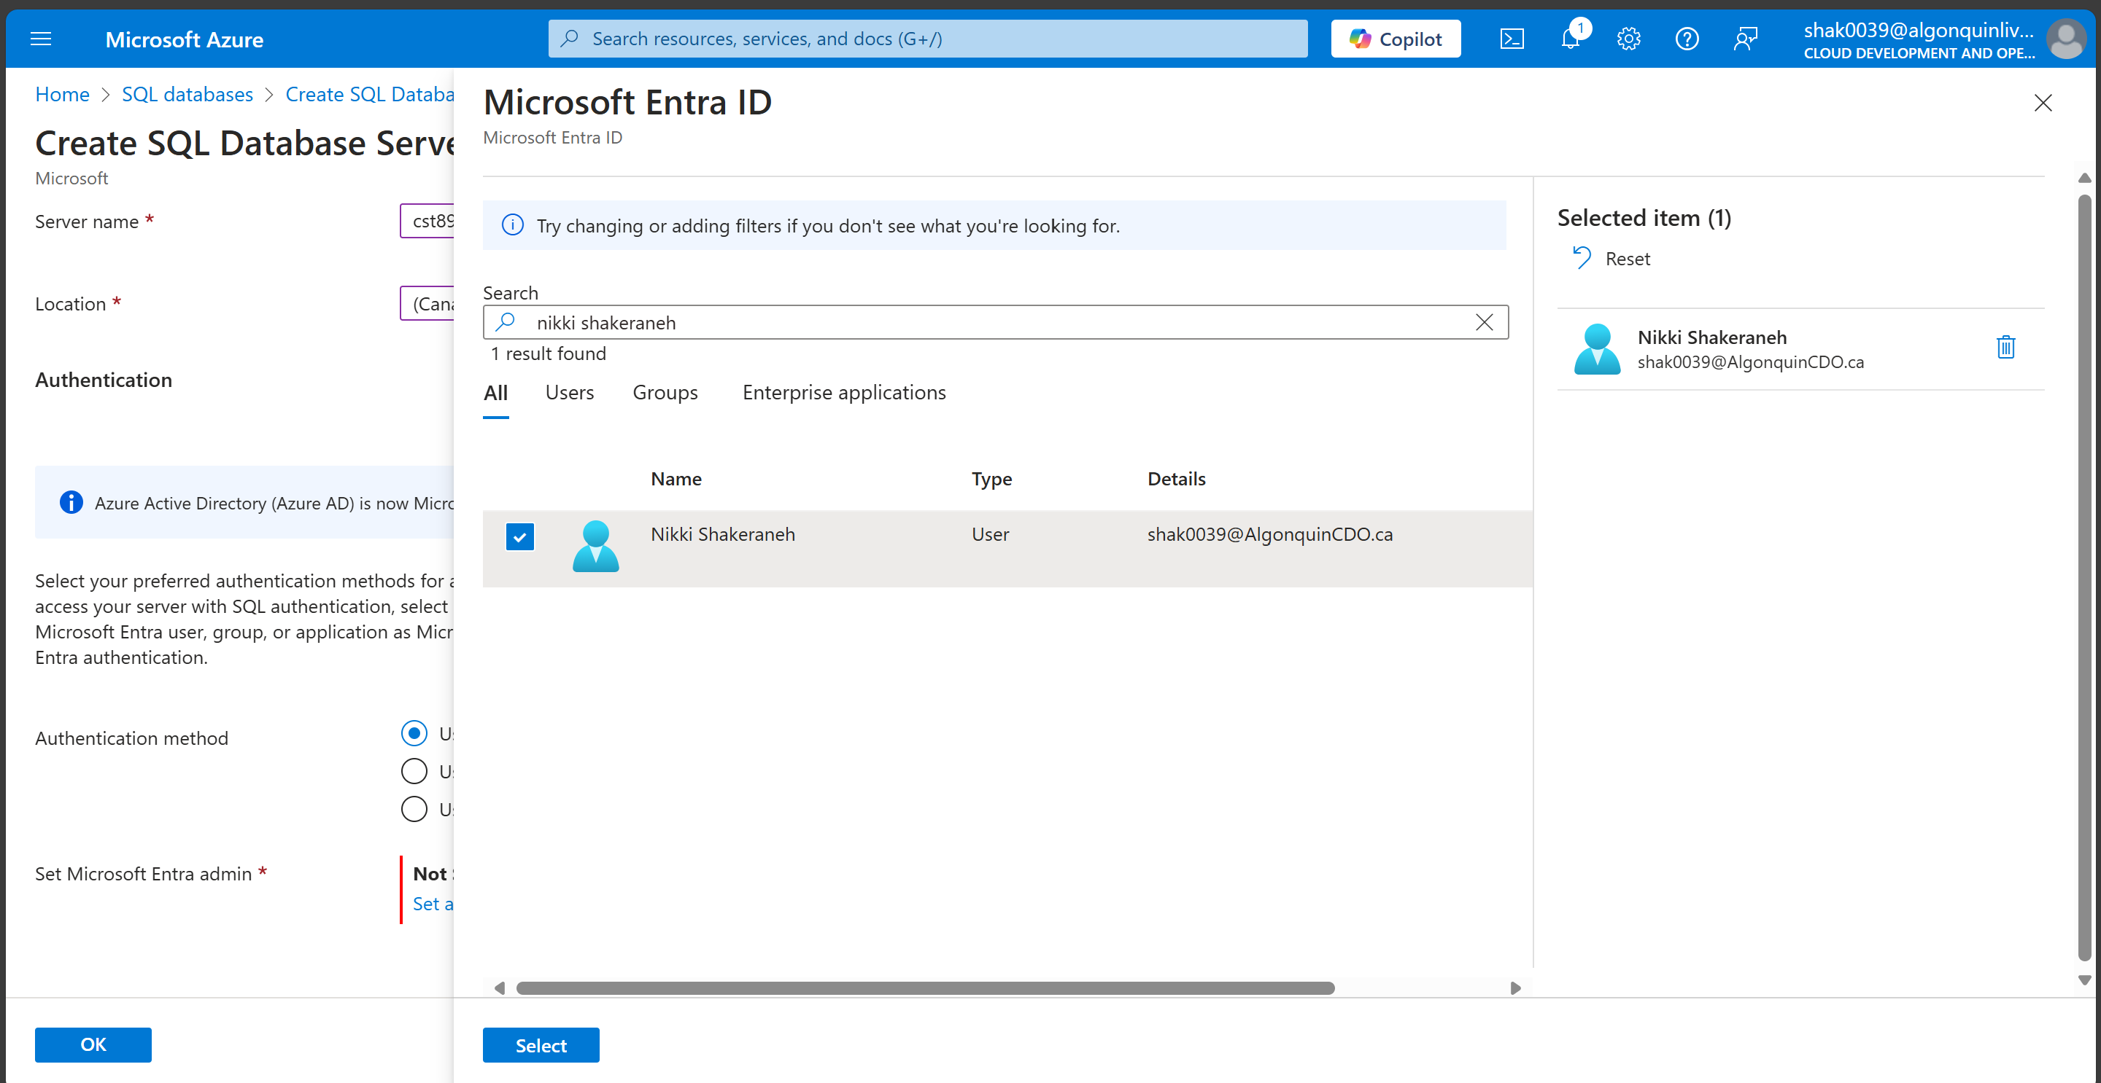

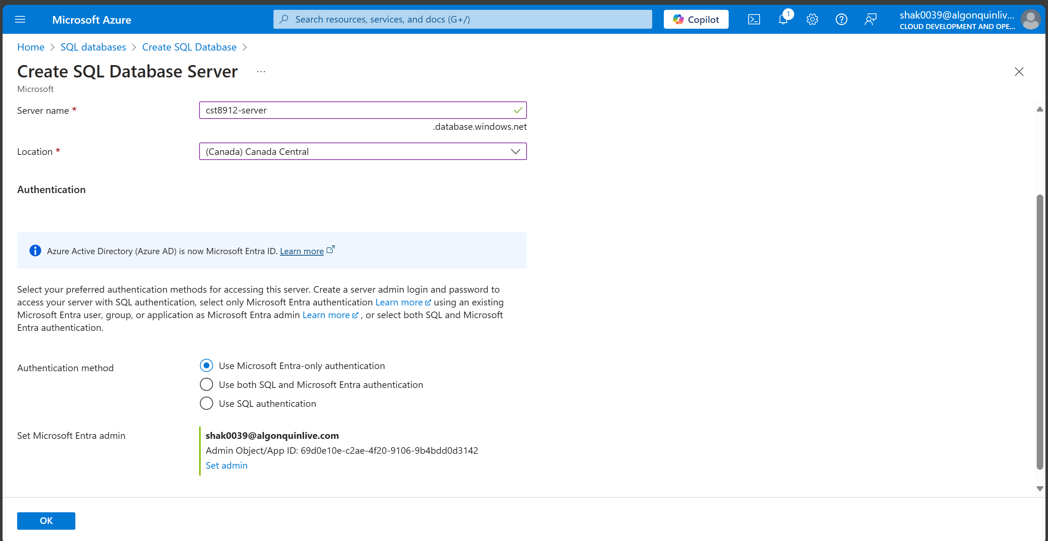

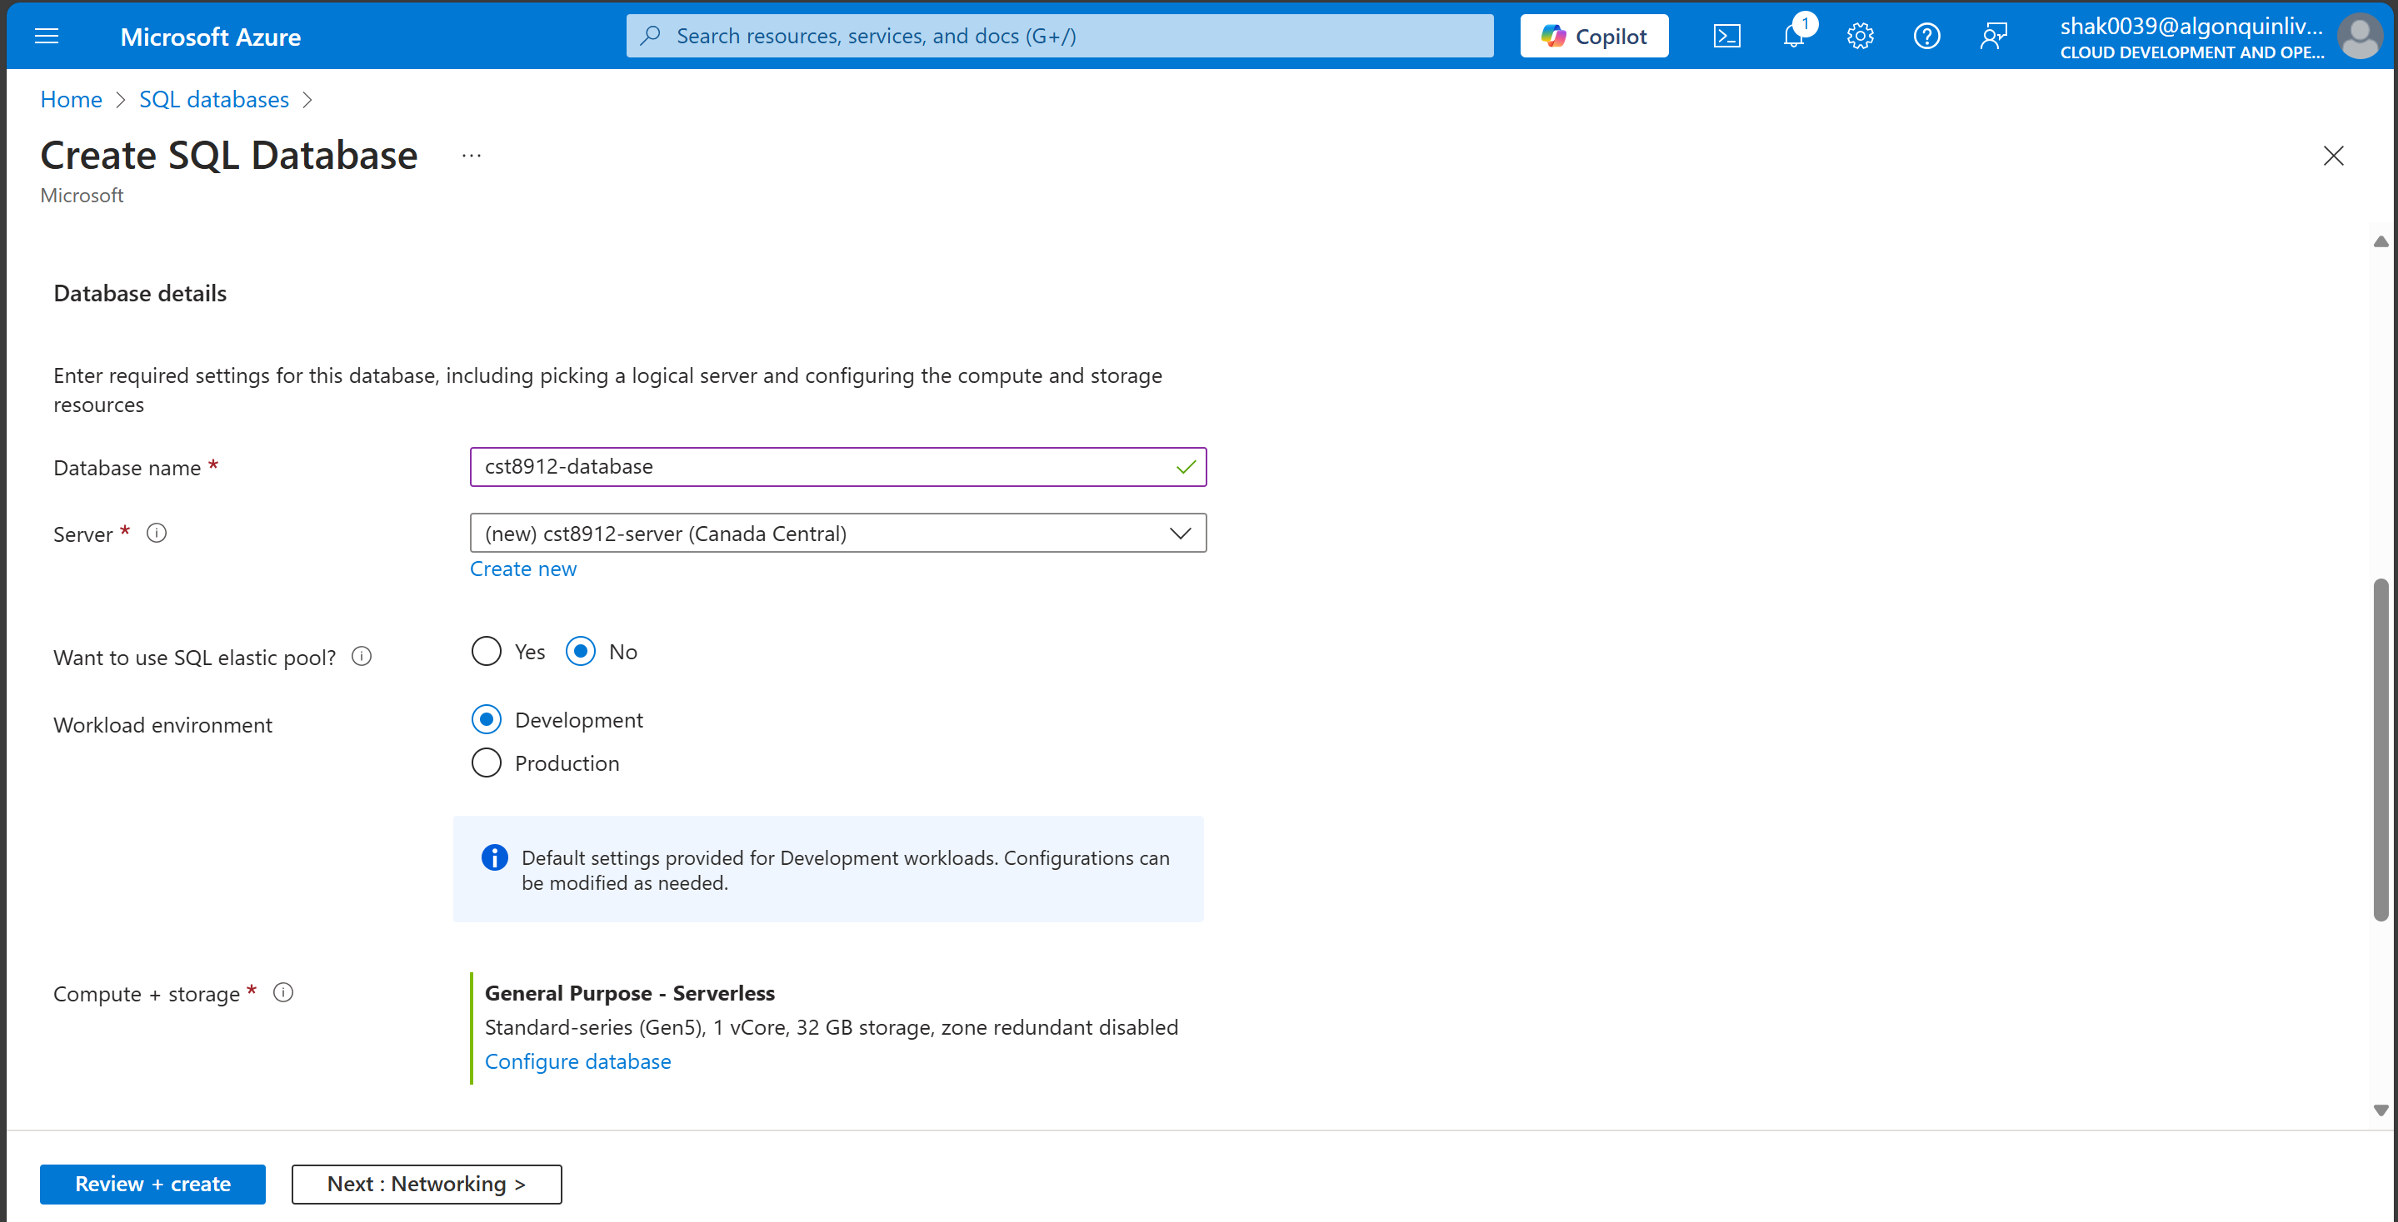

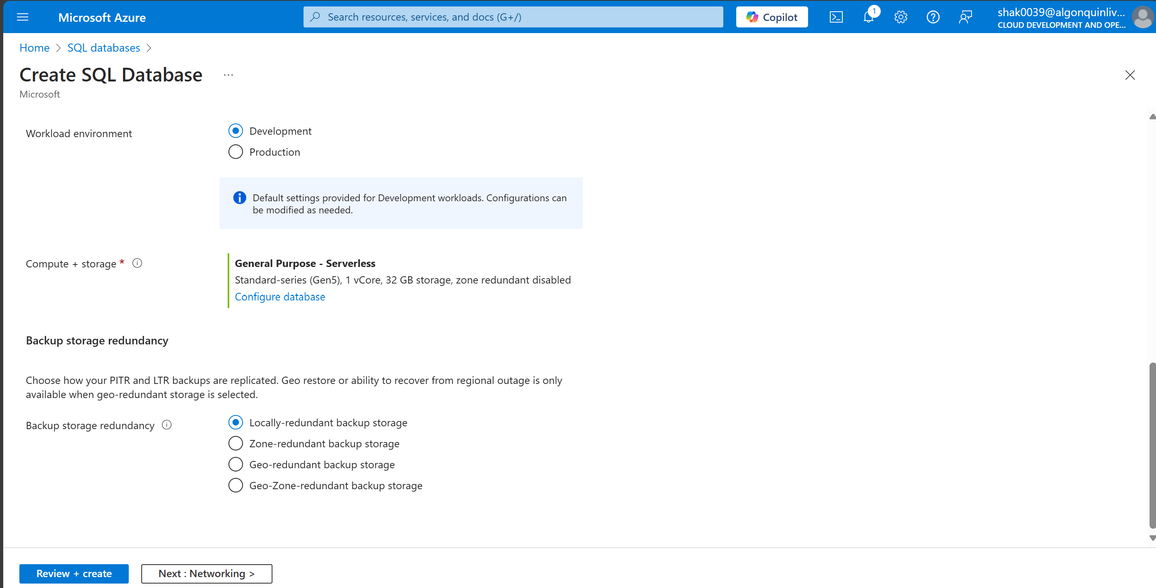

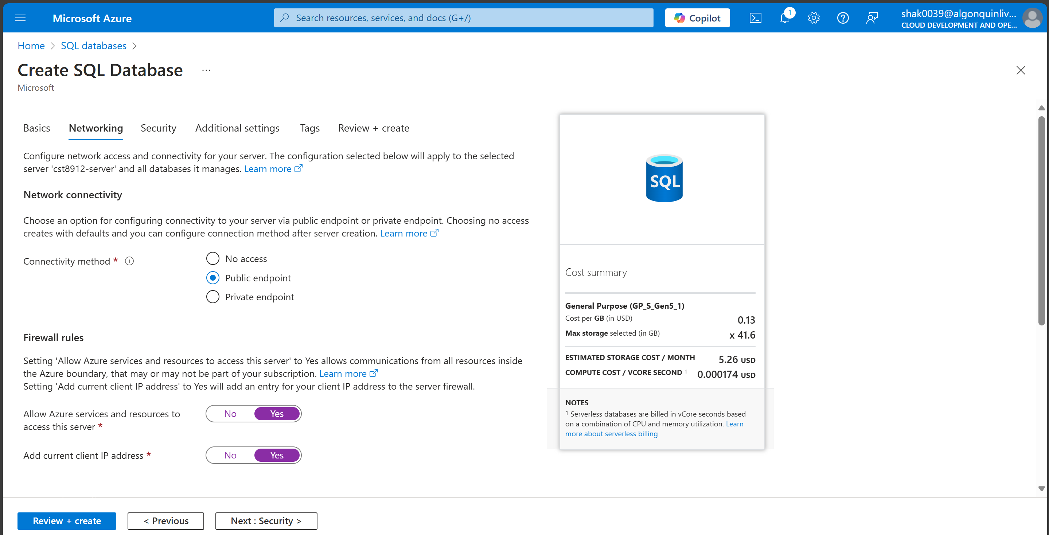

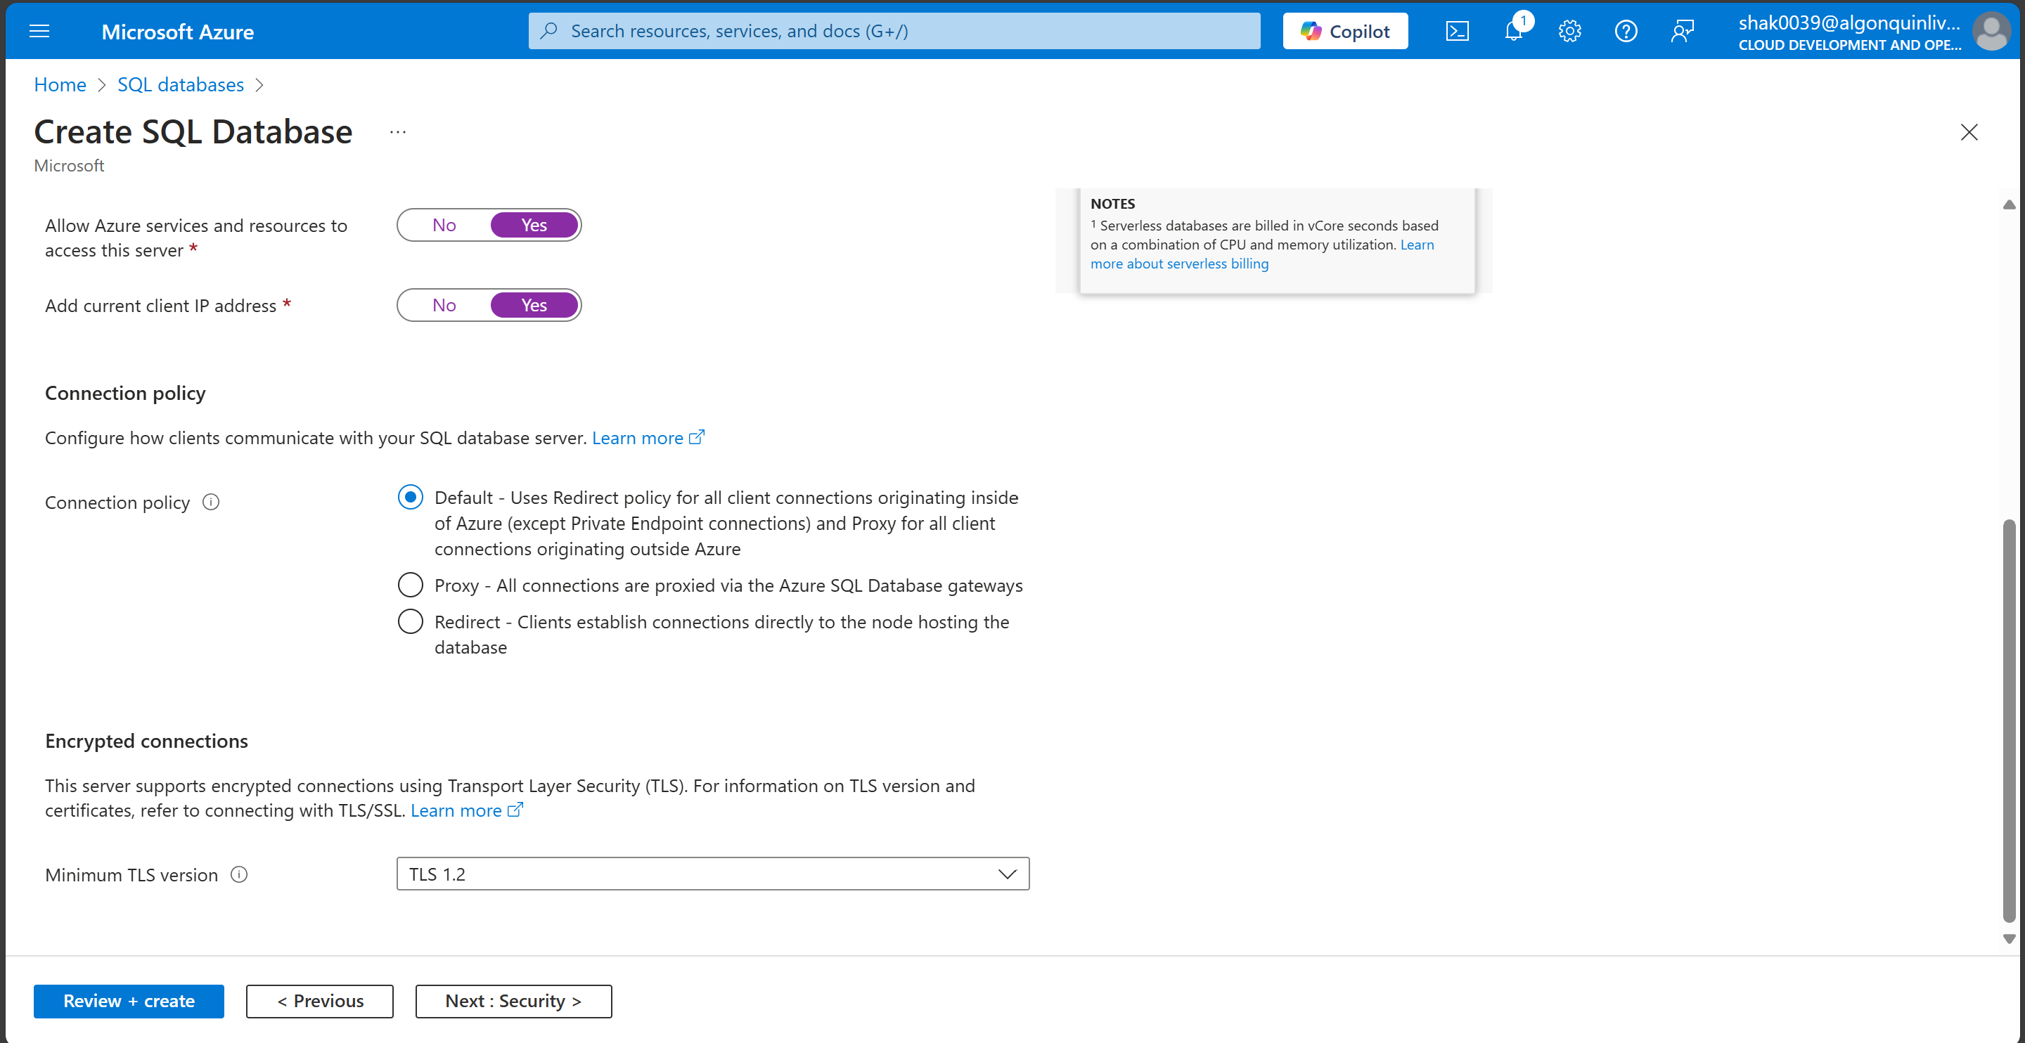

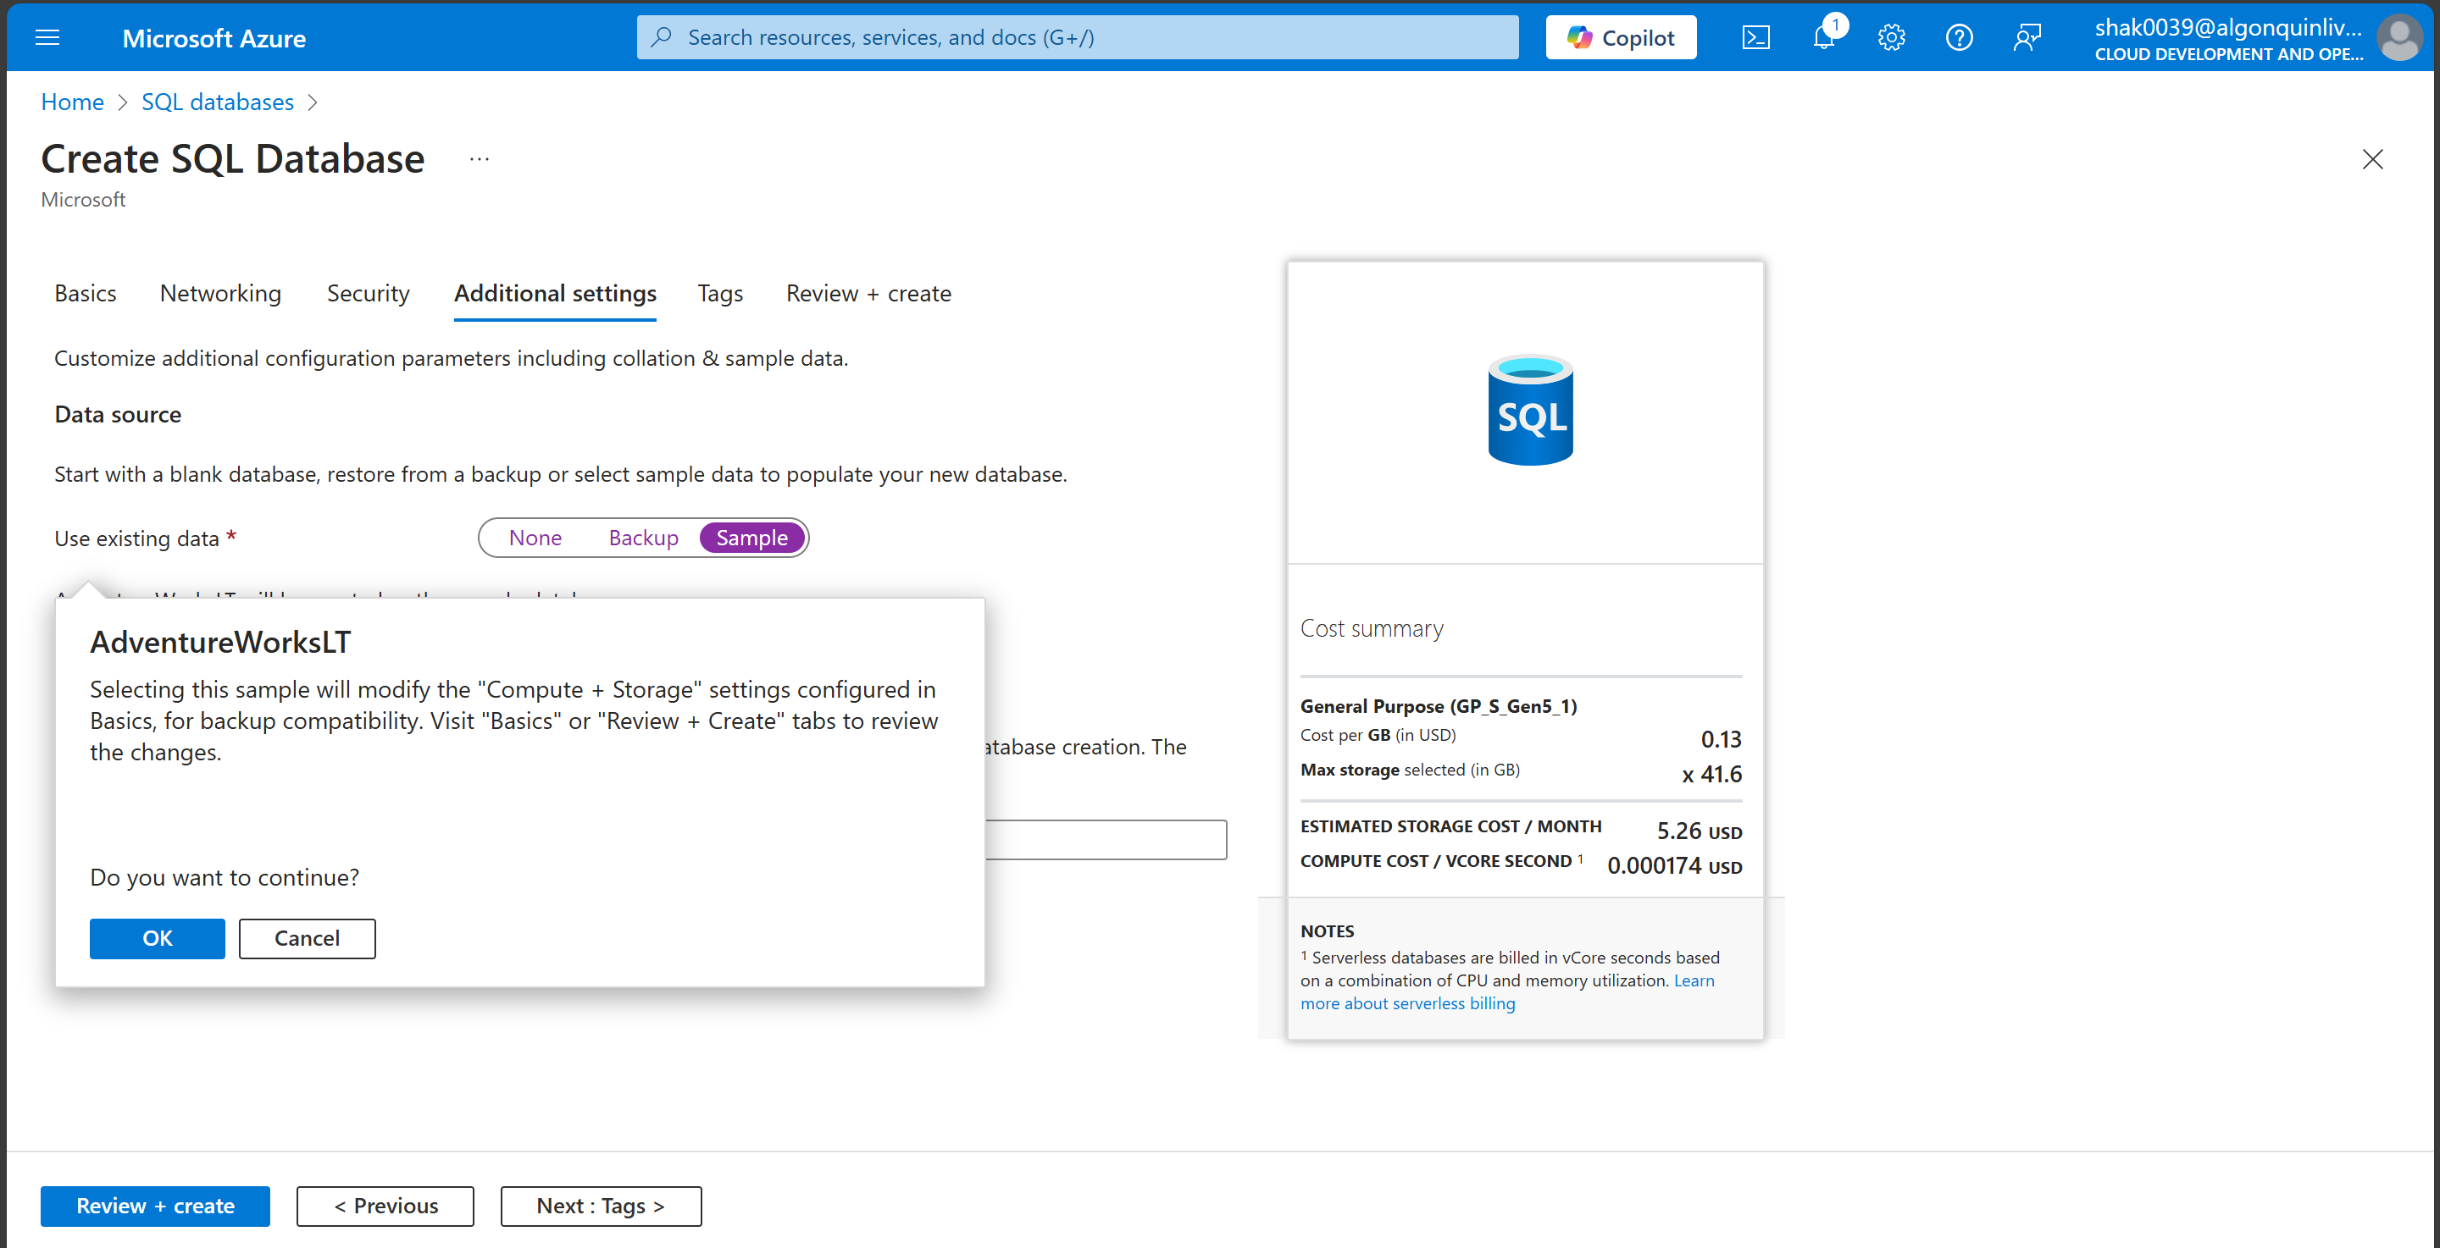

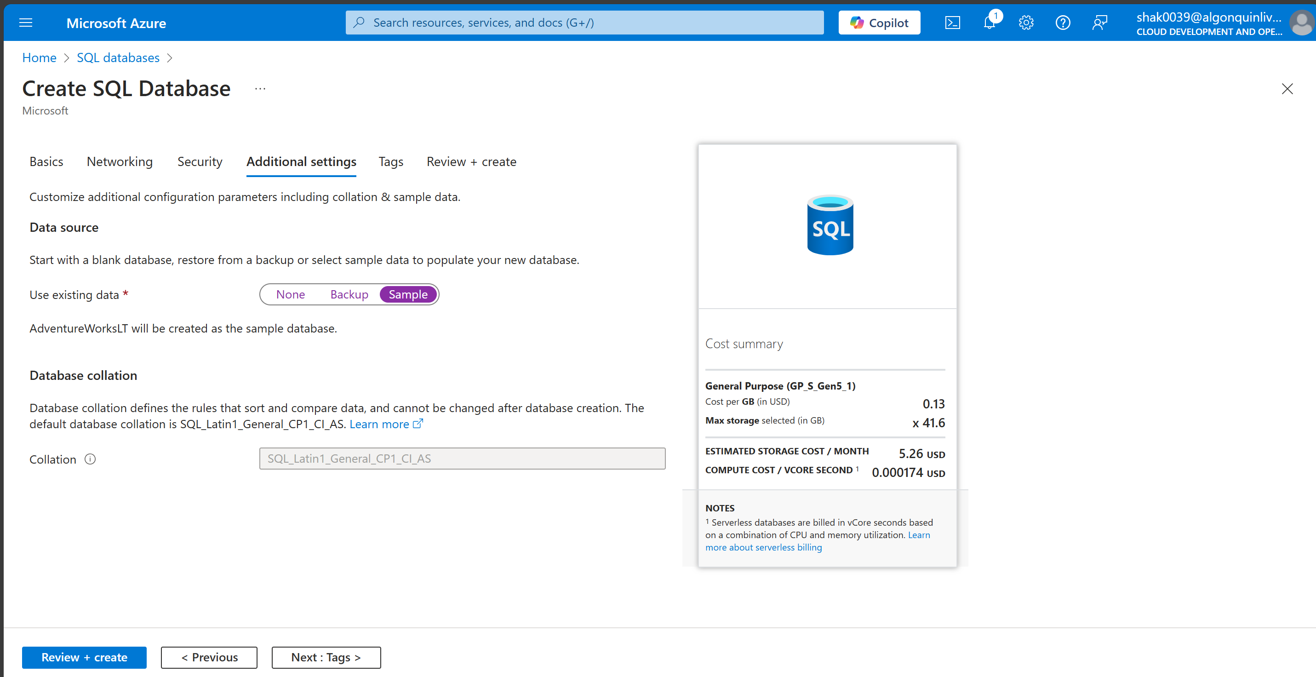

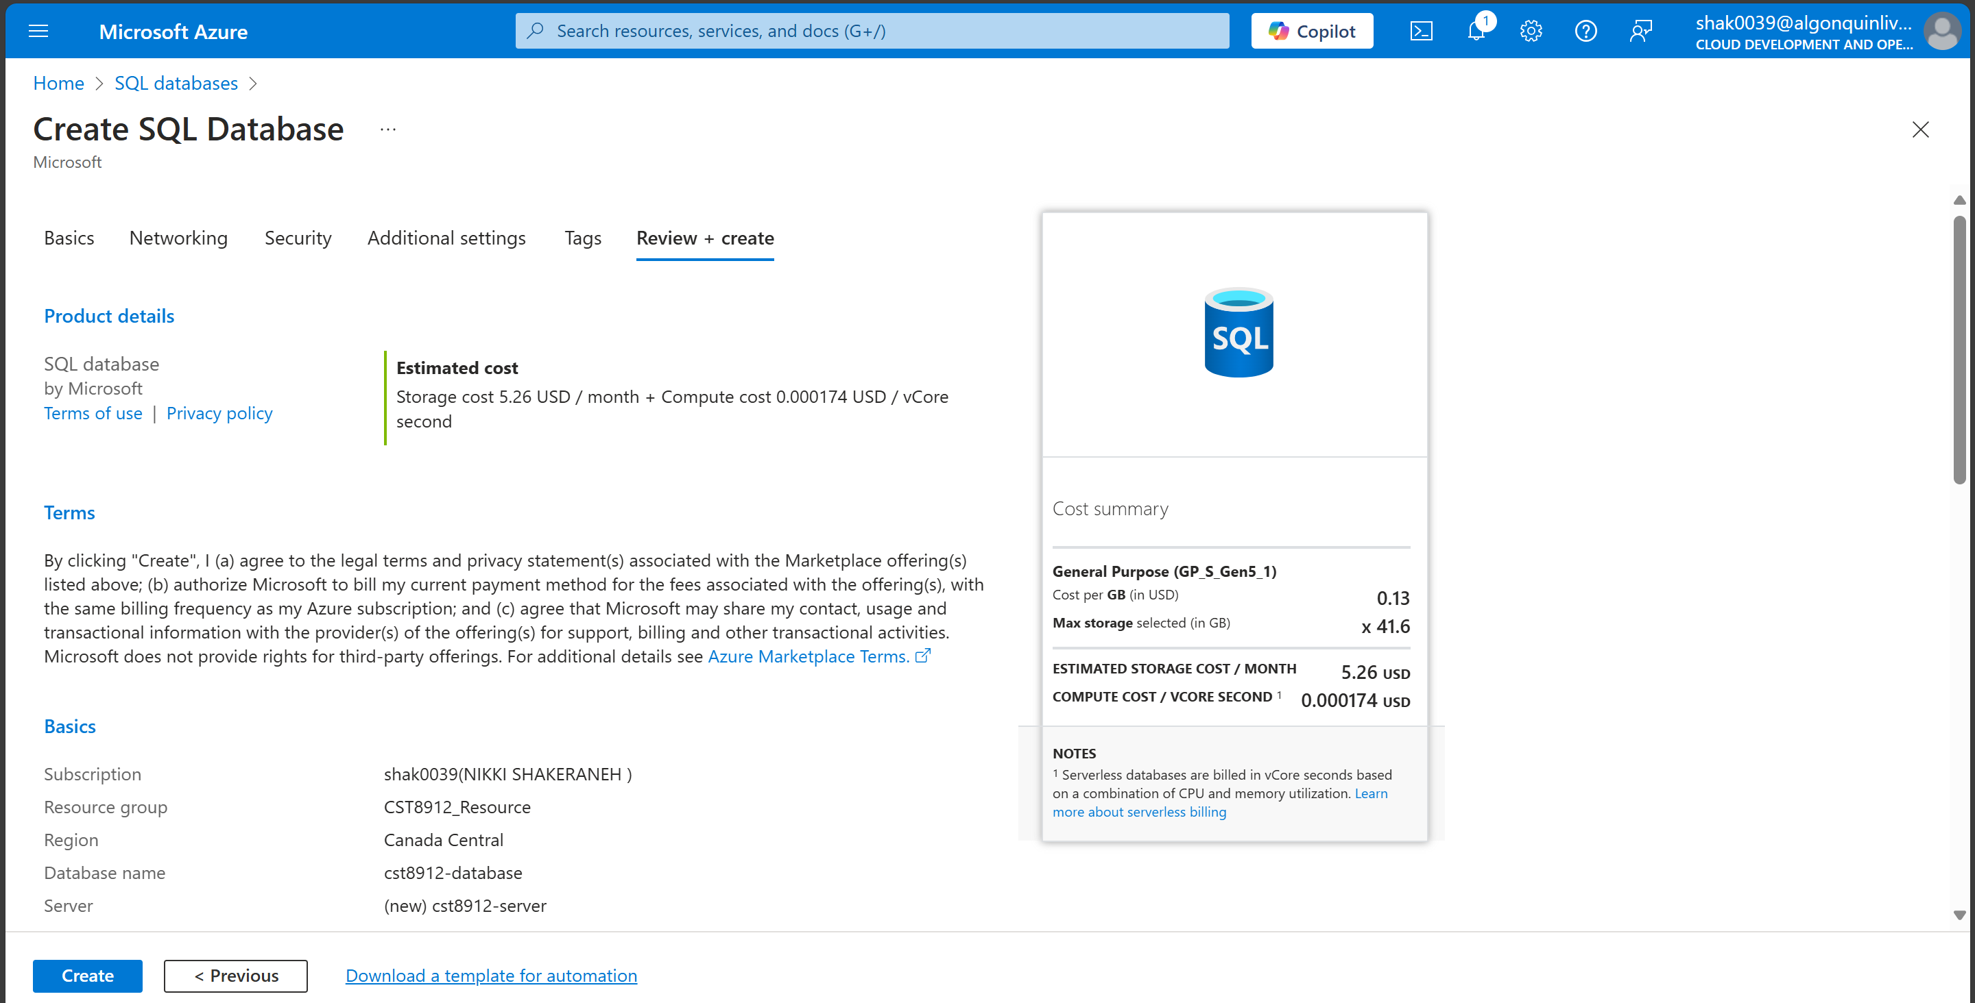

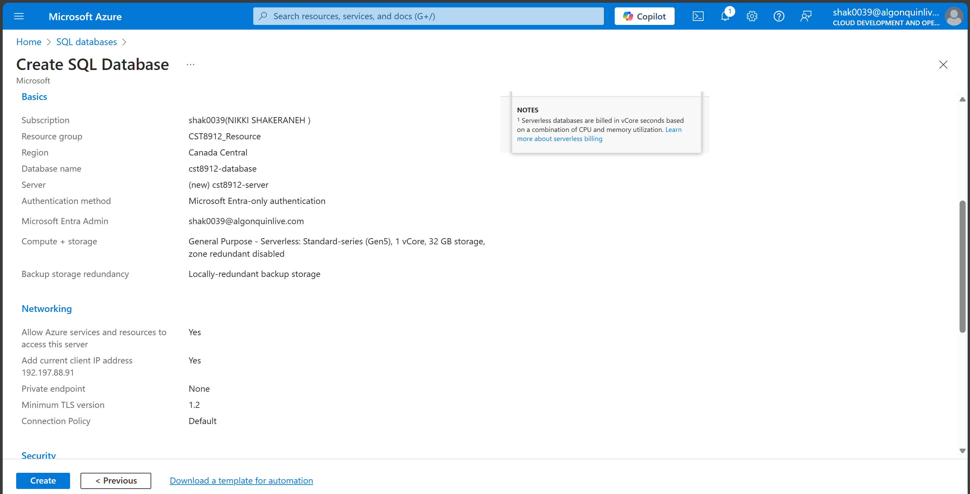

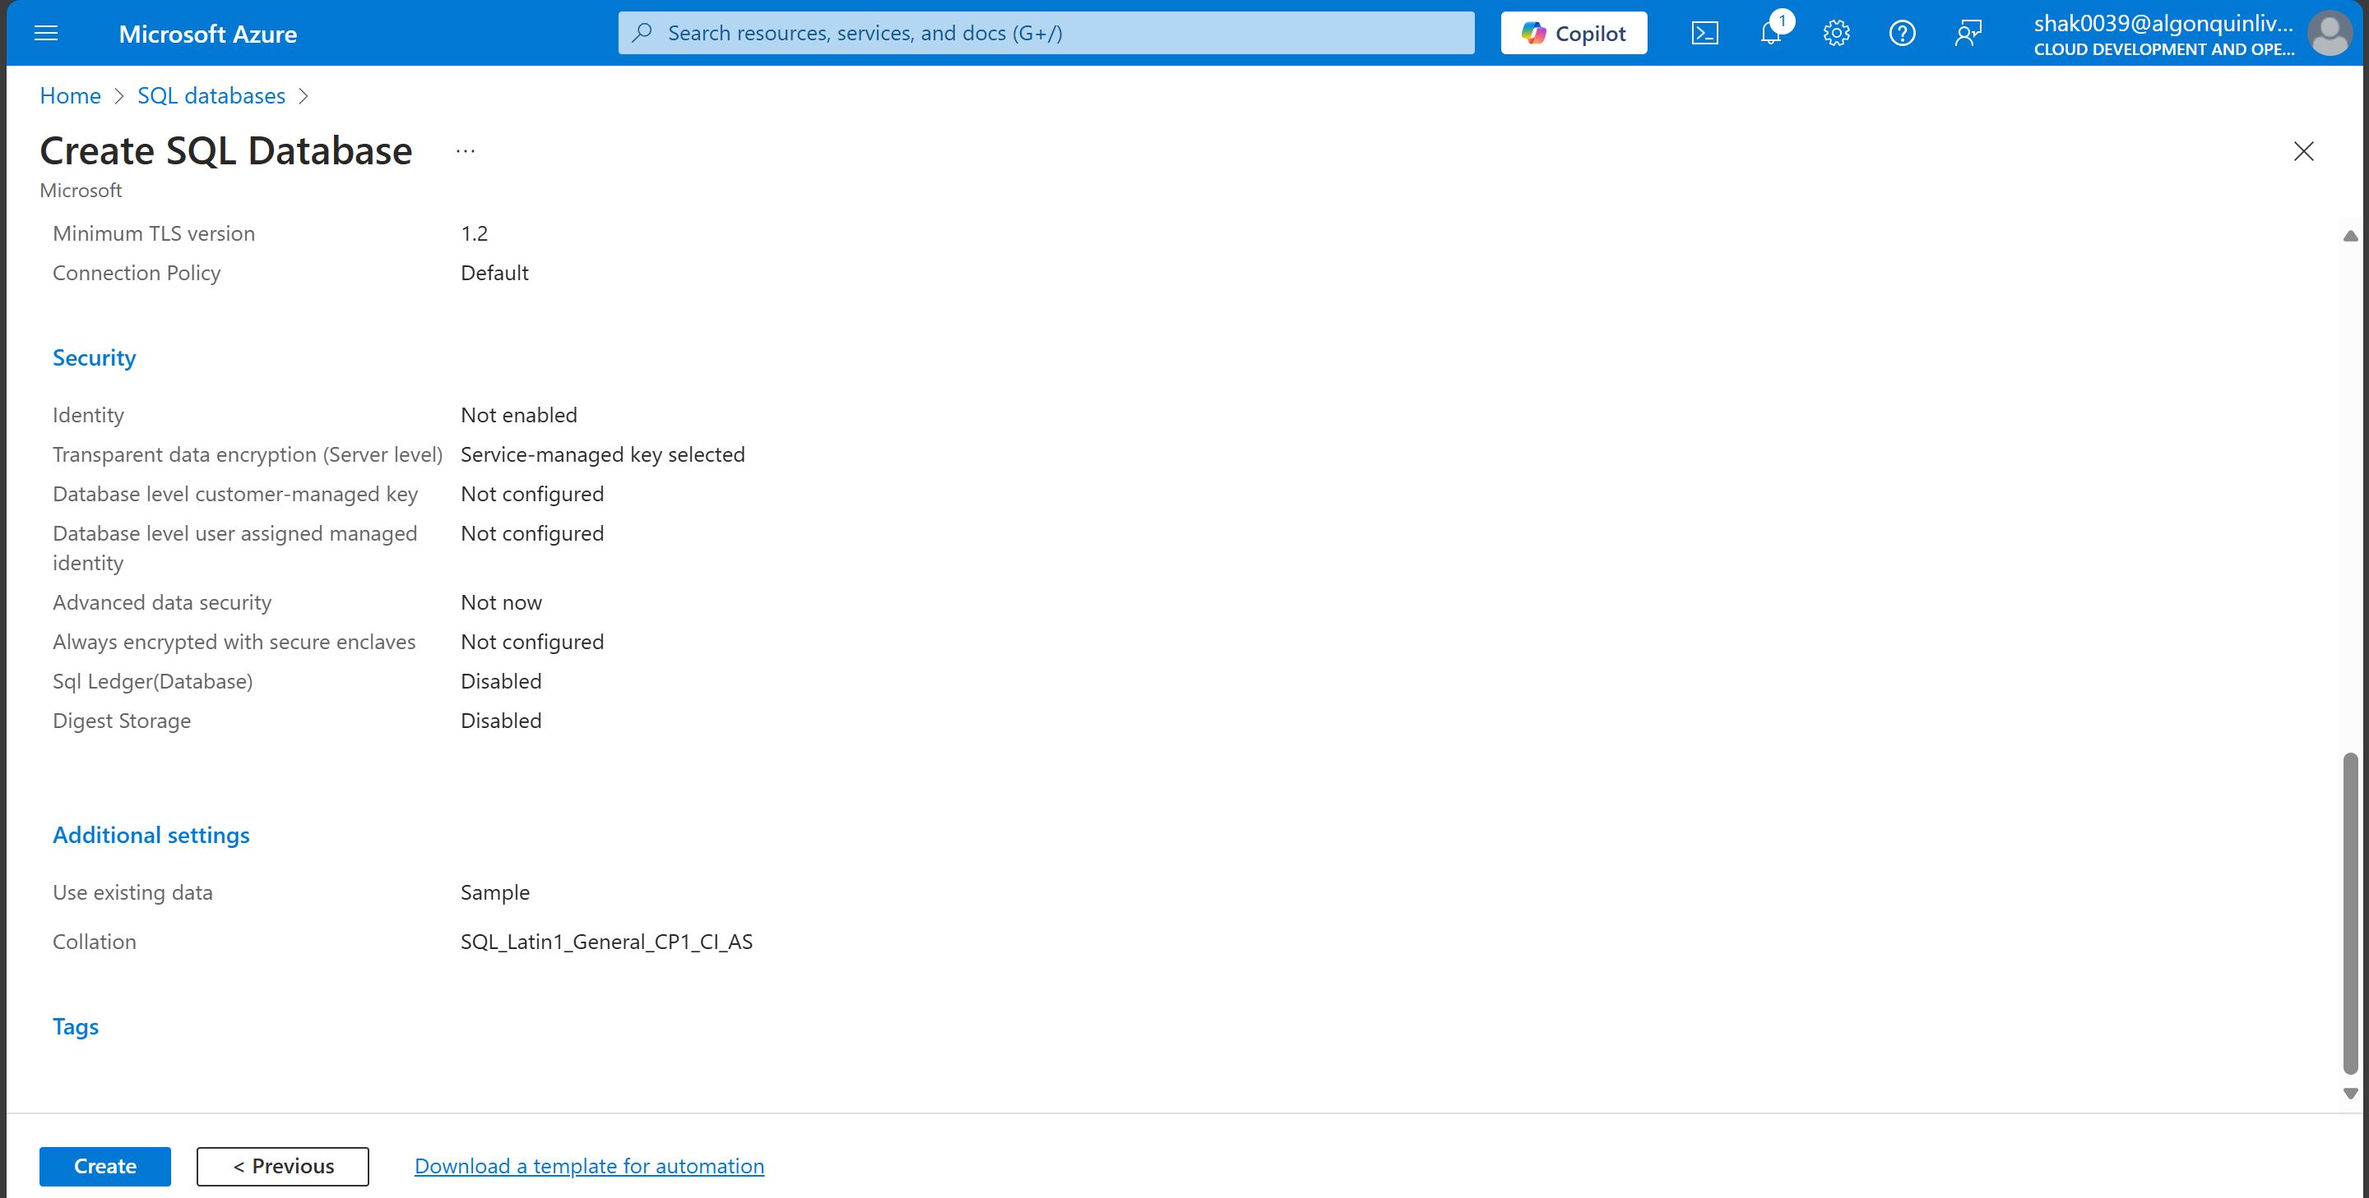

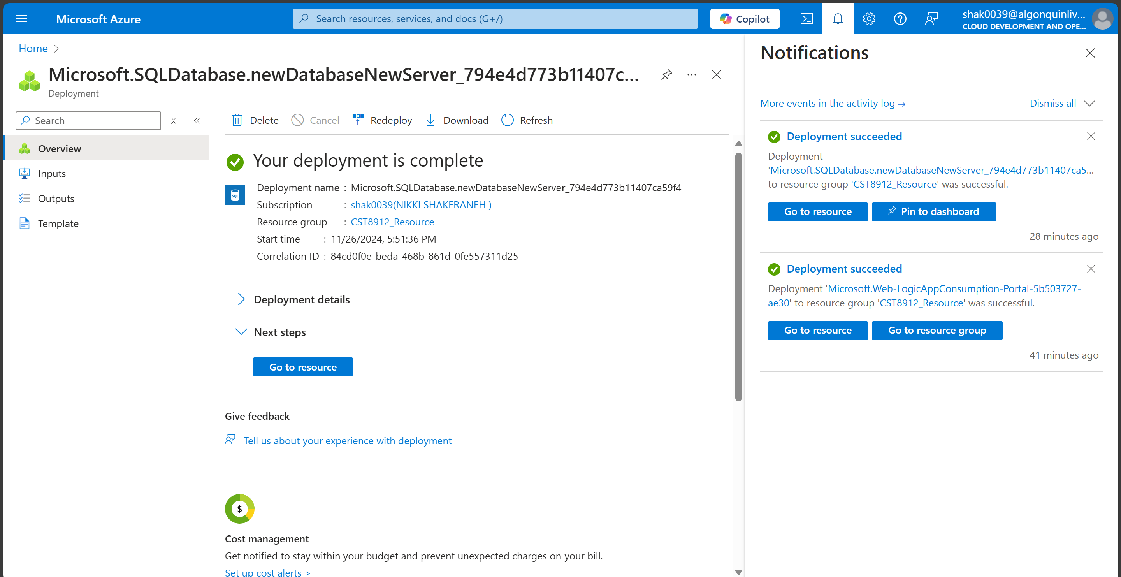

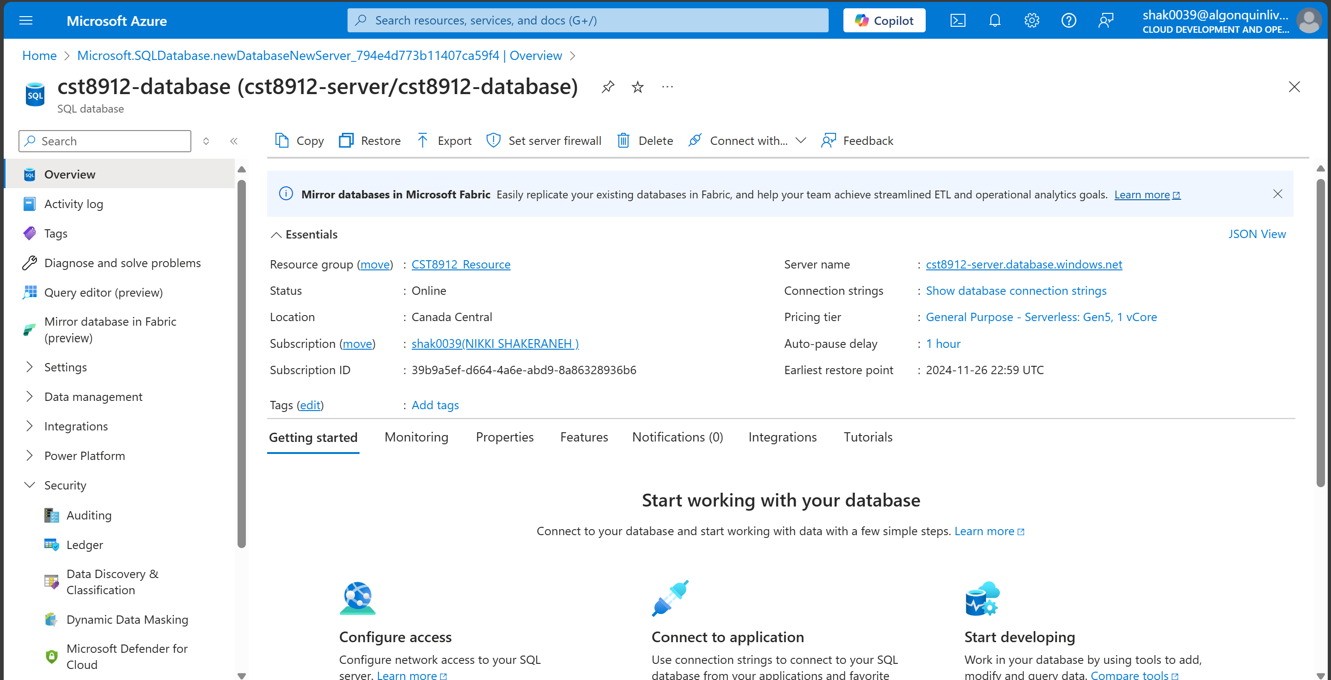

1. Create alerts table in sql database using query editor

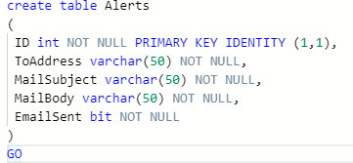

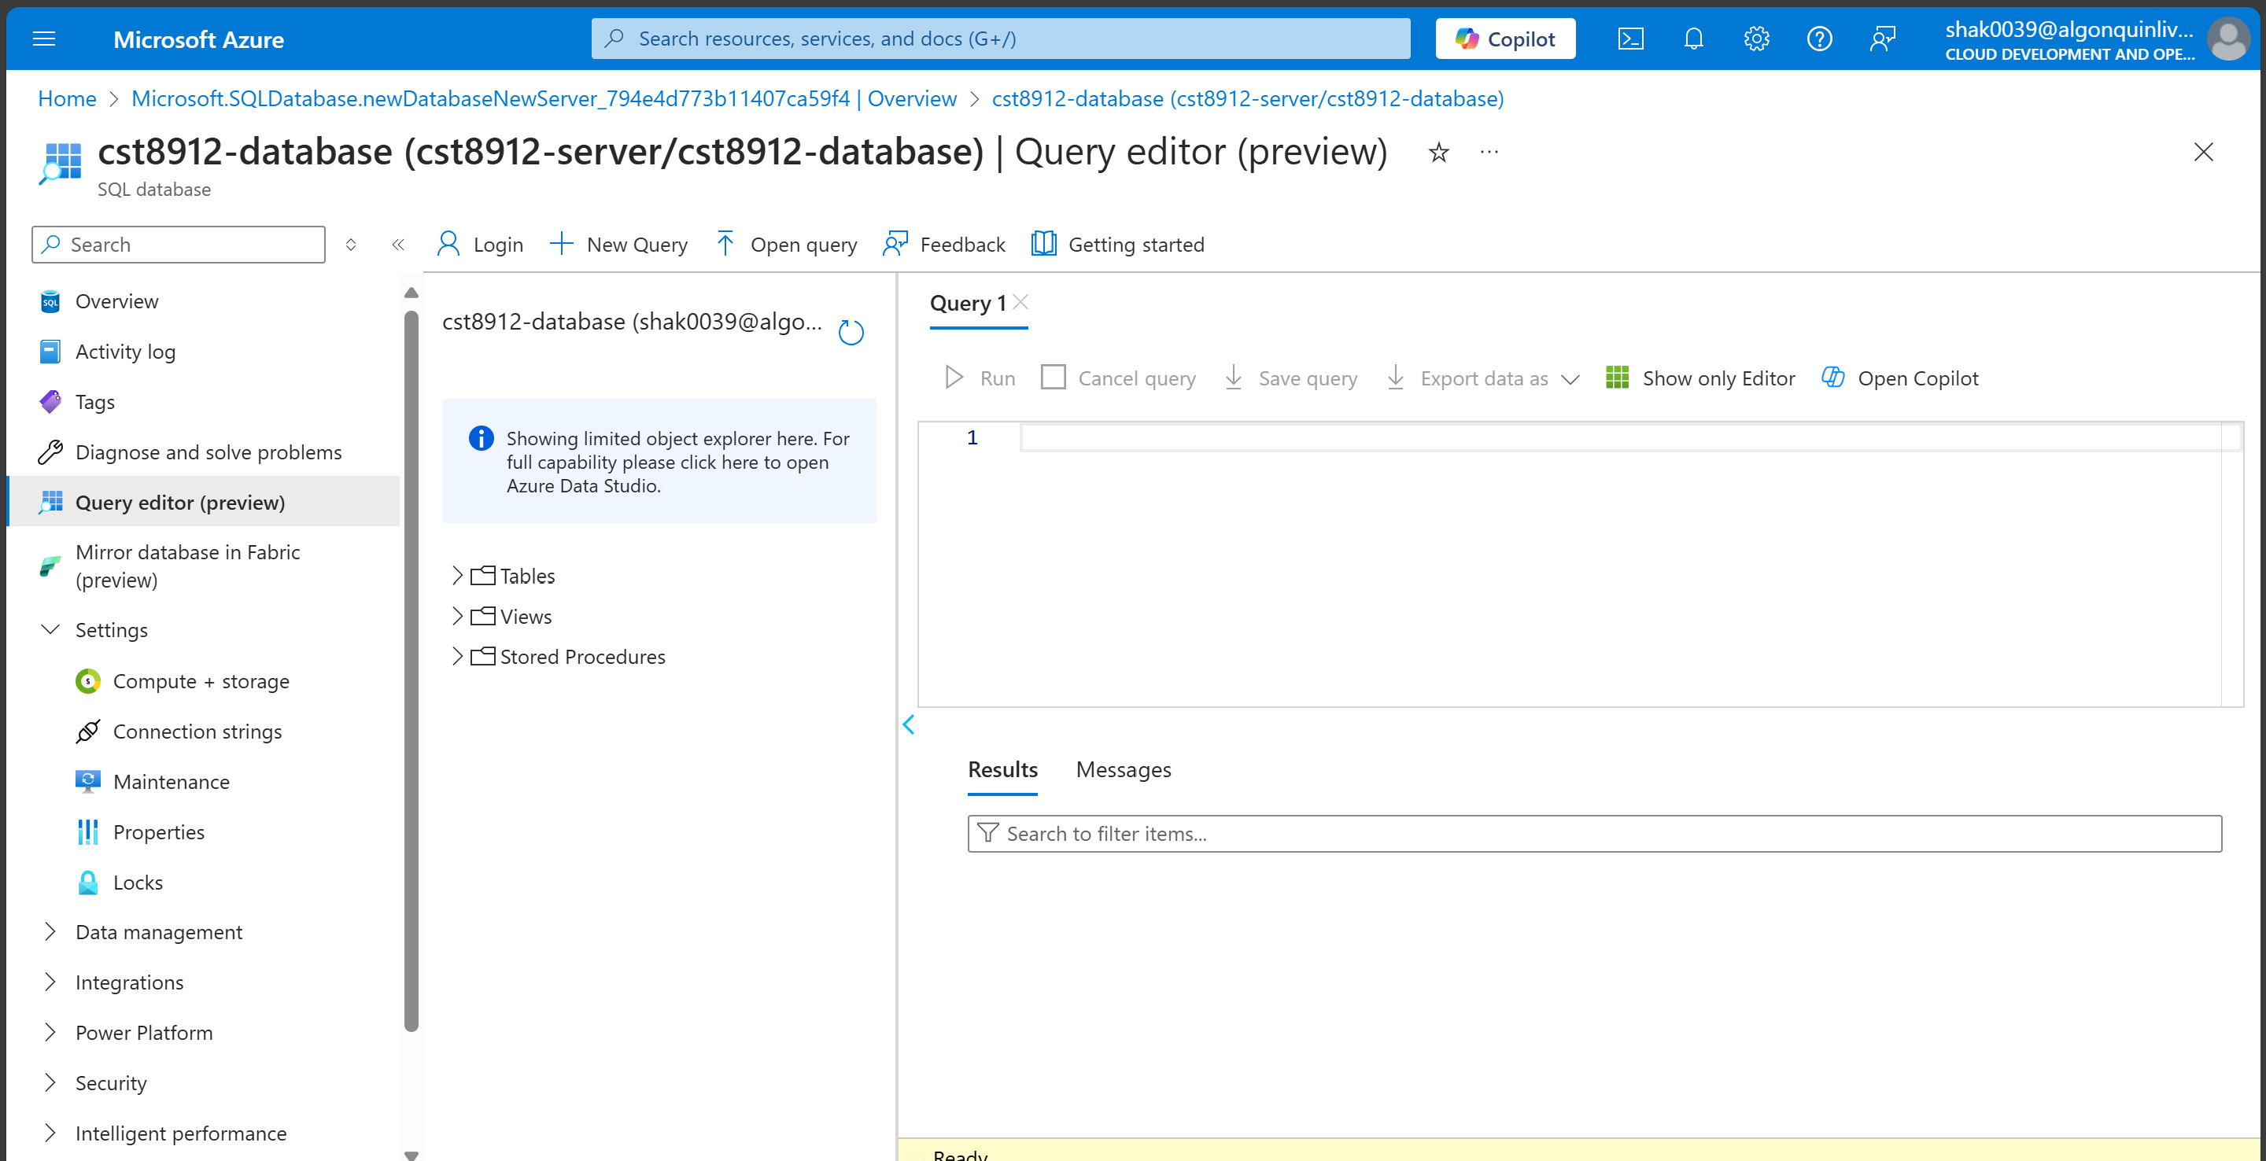

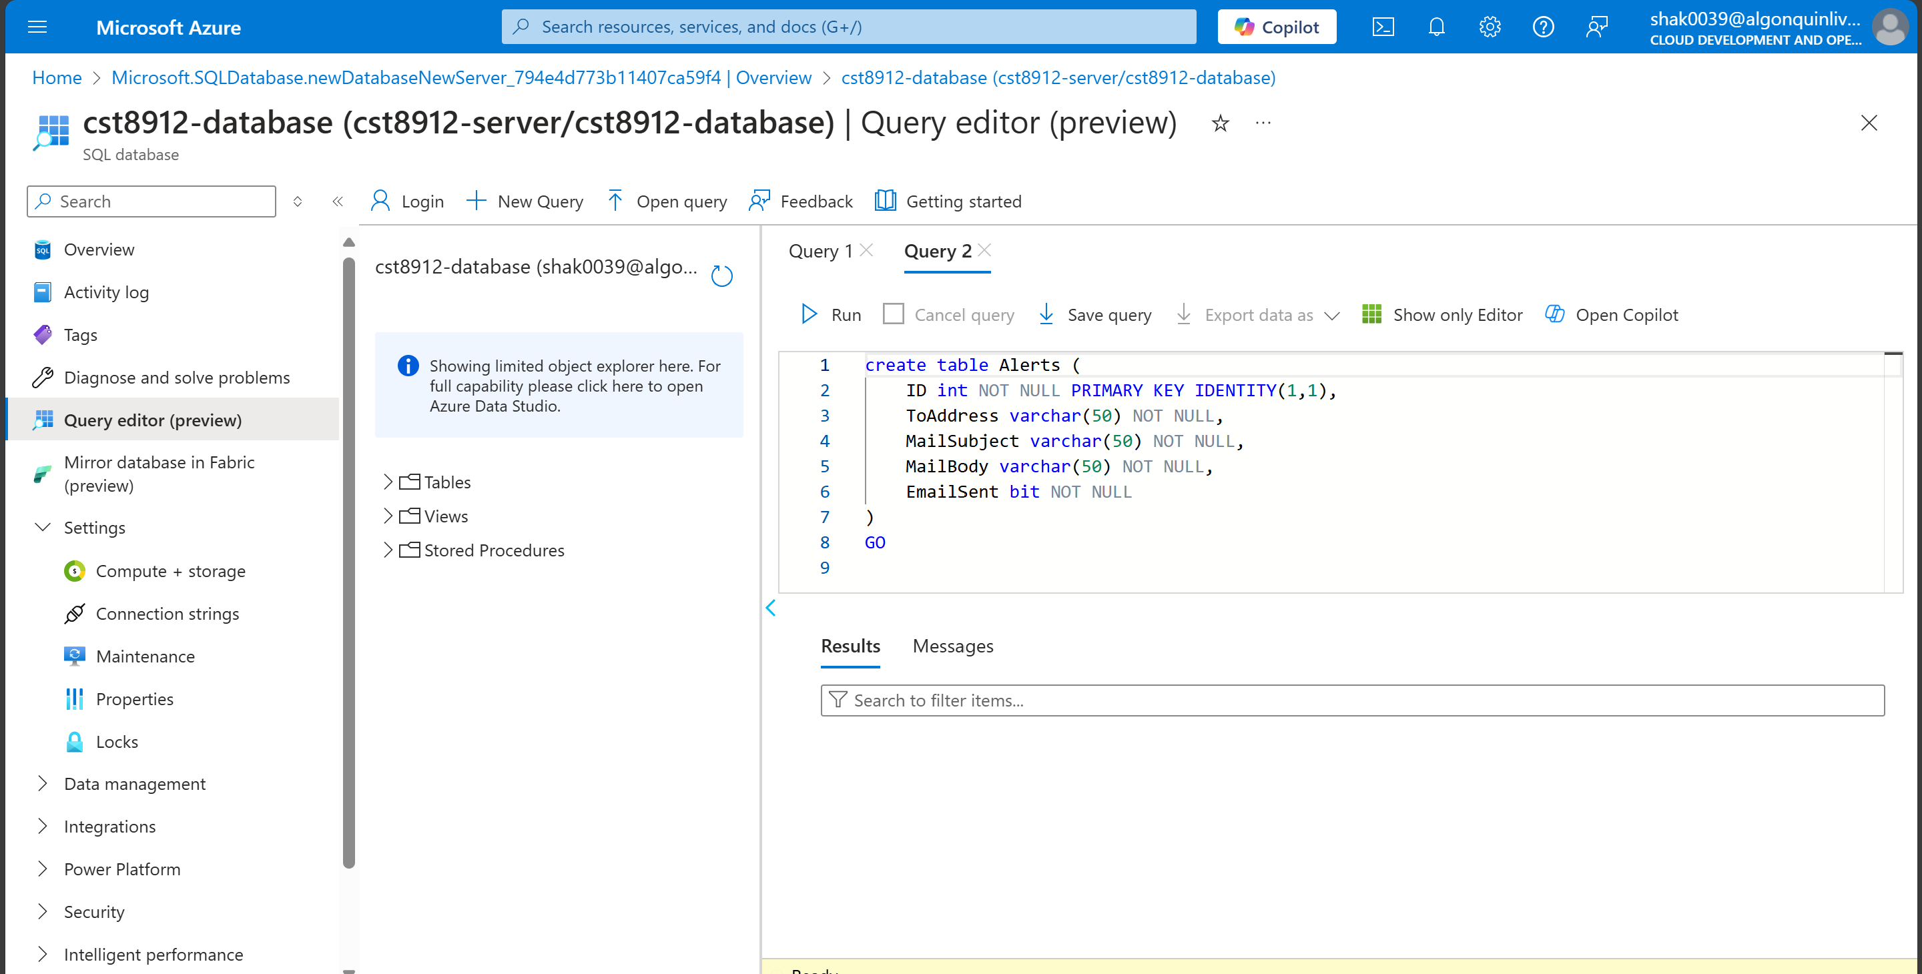

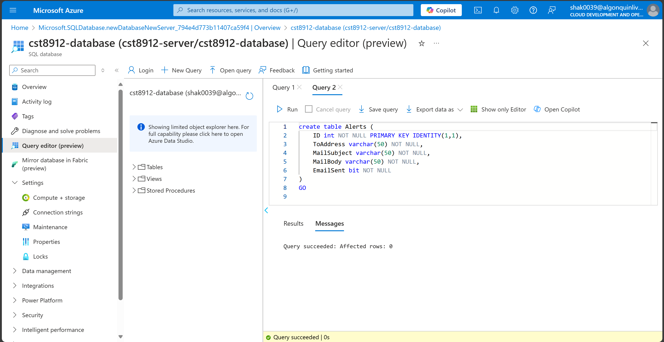

1. Insert records into the Alerts table using the query

Insert into [dbo].[Alerts] (ToAddress,MailSubject,MailBody,EmailSent)

values ('youremail','demoApp1','This is message body1',0)

go

Insert into [dbo].[Alerts] (ToAddress,MailSubject,MailBody,EmailSent)

values ('youremail','demoApp2','This is message body2',0)

go

Insert into [dbo].[Alerts] (ToAddress,MailSubject,MailBody,EmailSent)

values ('youremail','demoApp3','This is message body3',0)

go

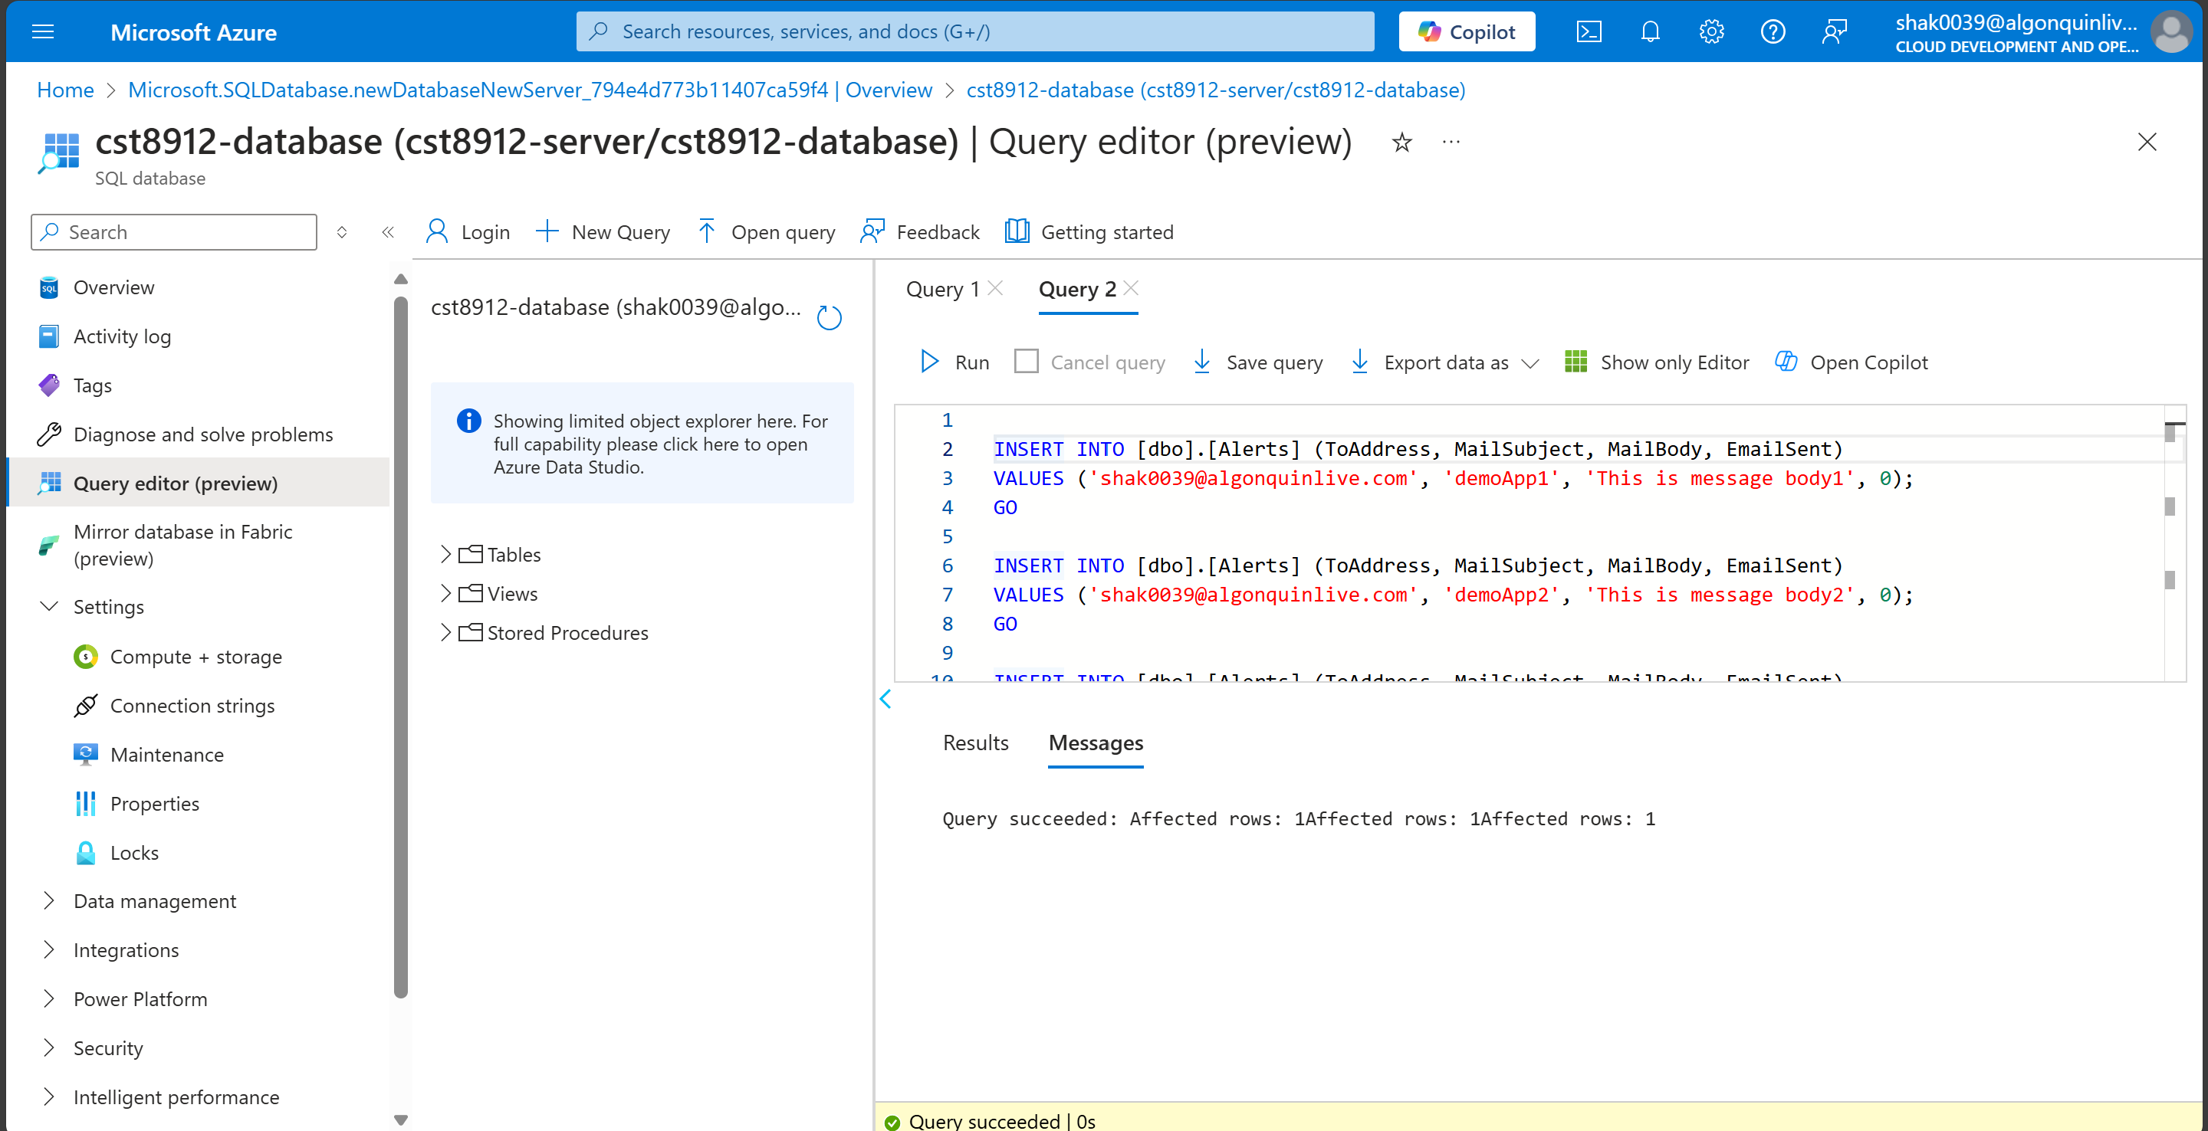

1. Select rows from db.Alerts table to verify the records inserted in the table.

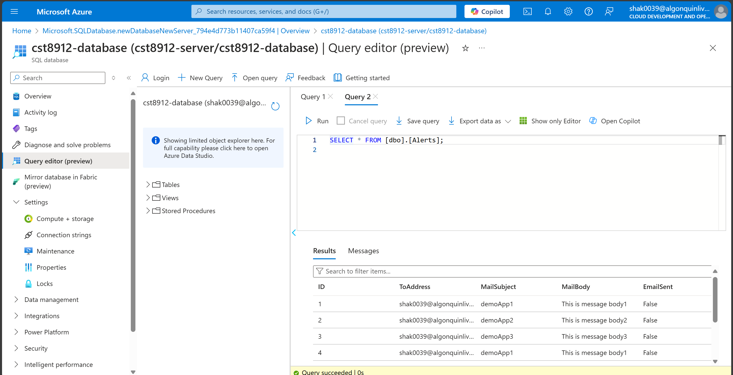

1. Go to logic app created in lab

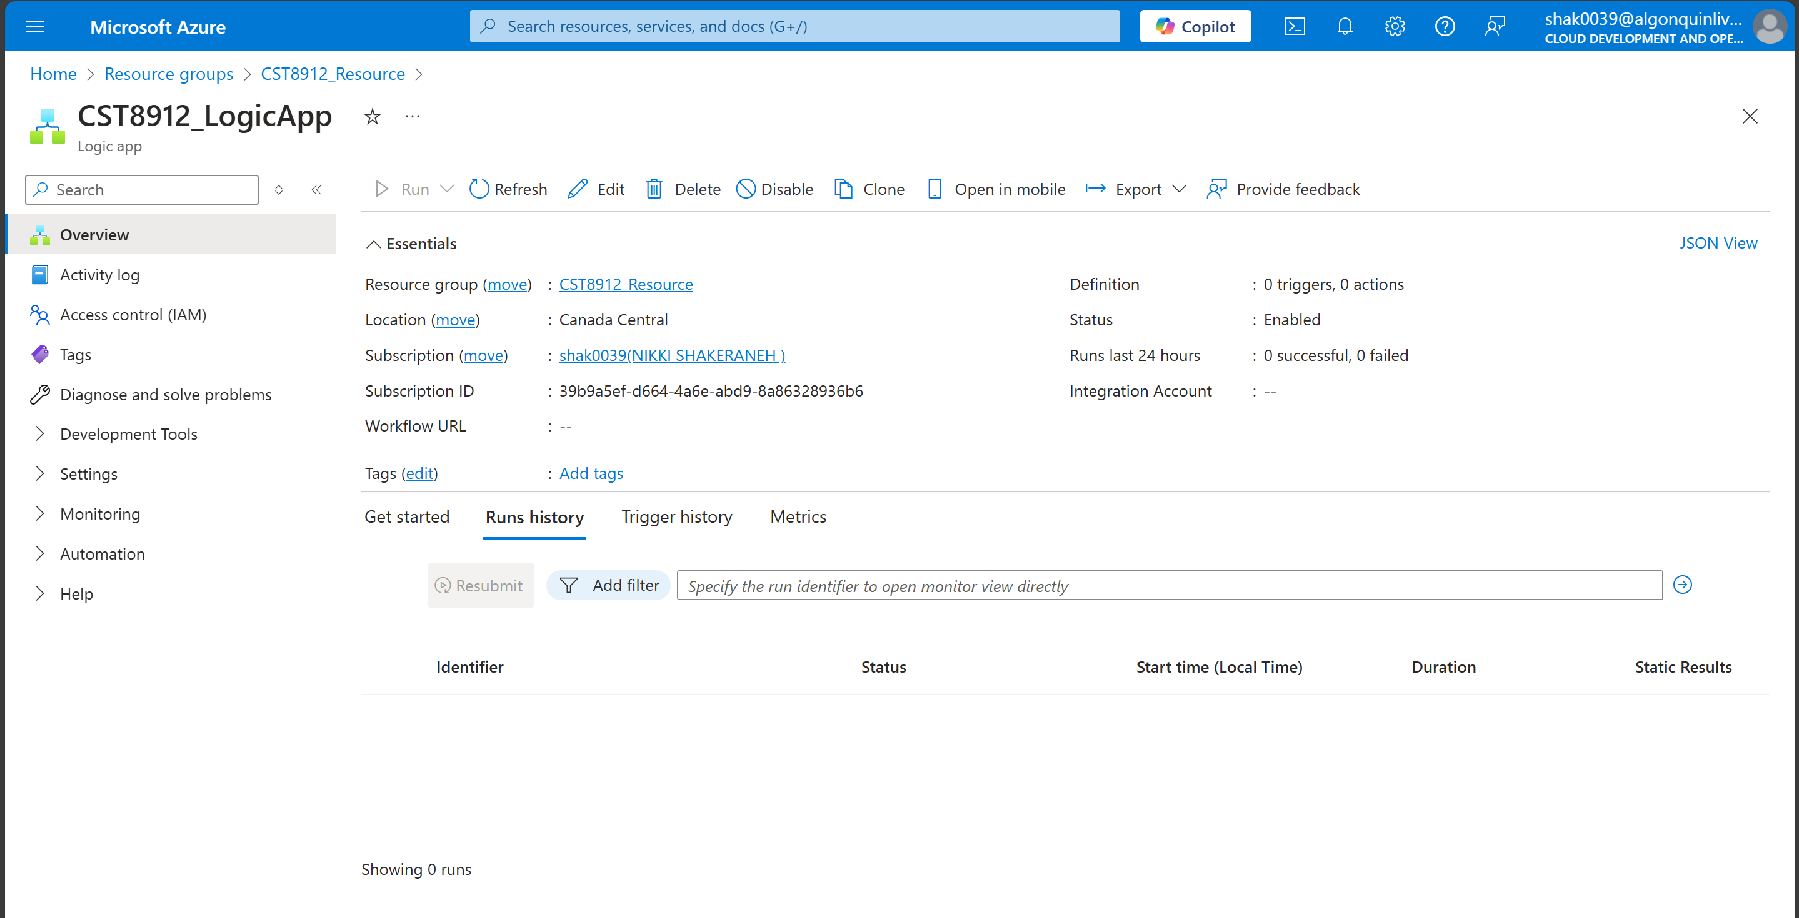

1. Use recurrence trigger and define values for interval (3) and frequency (minute)

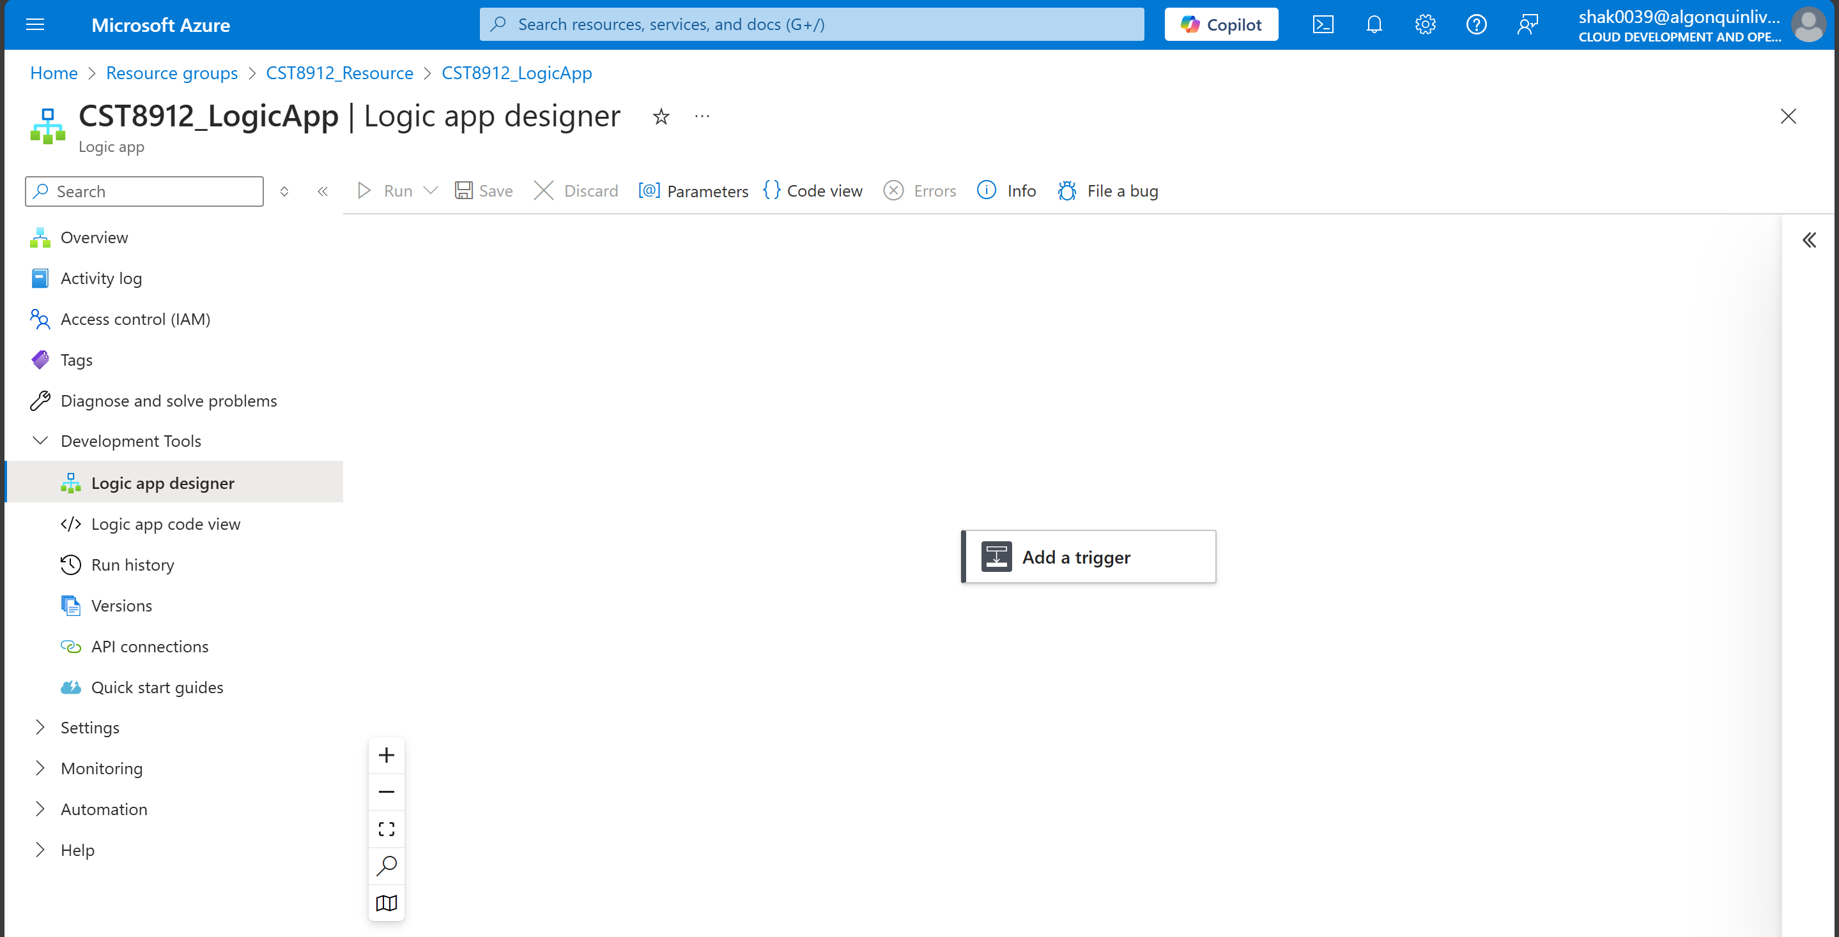

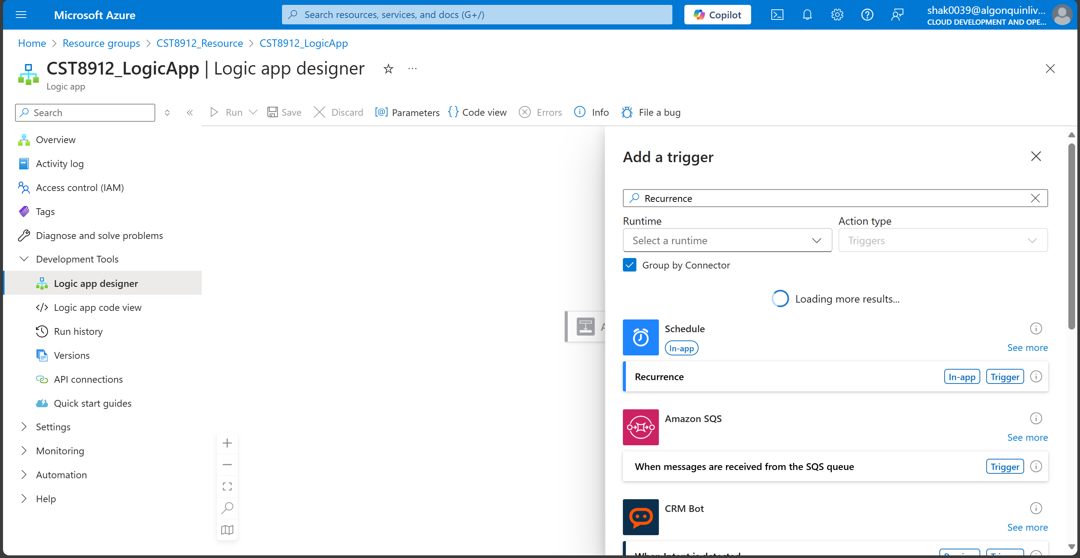

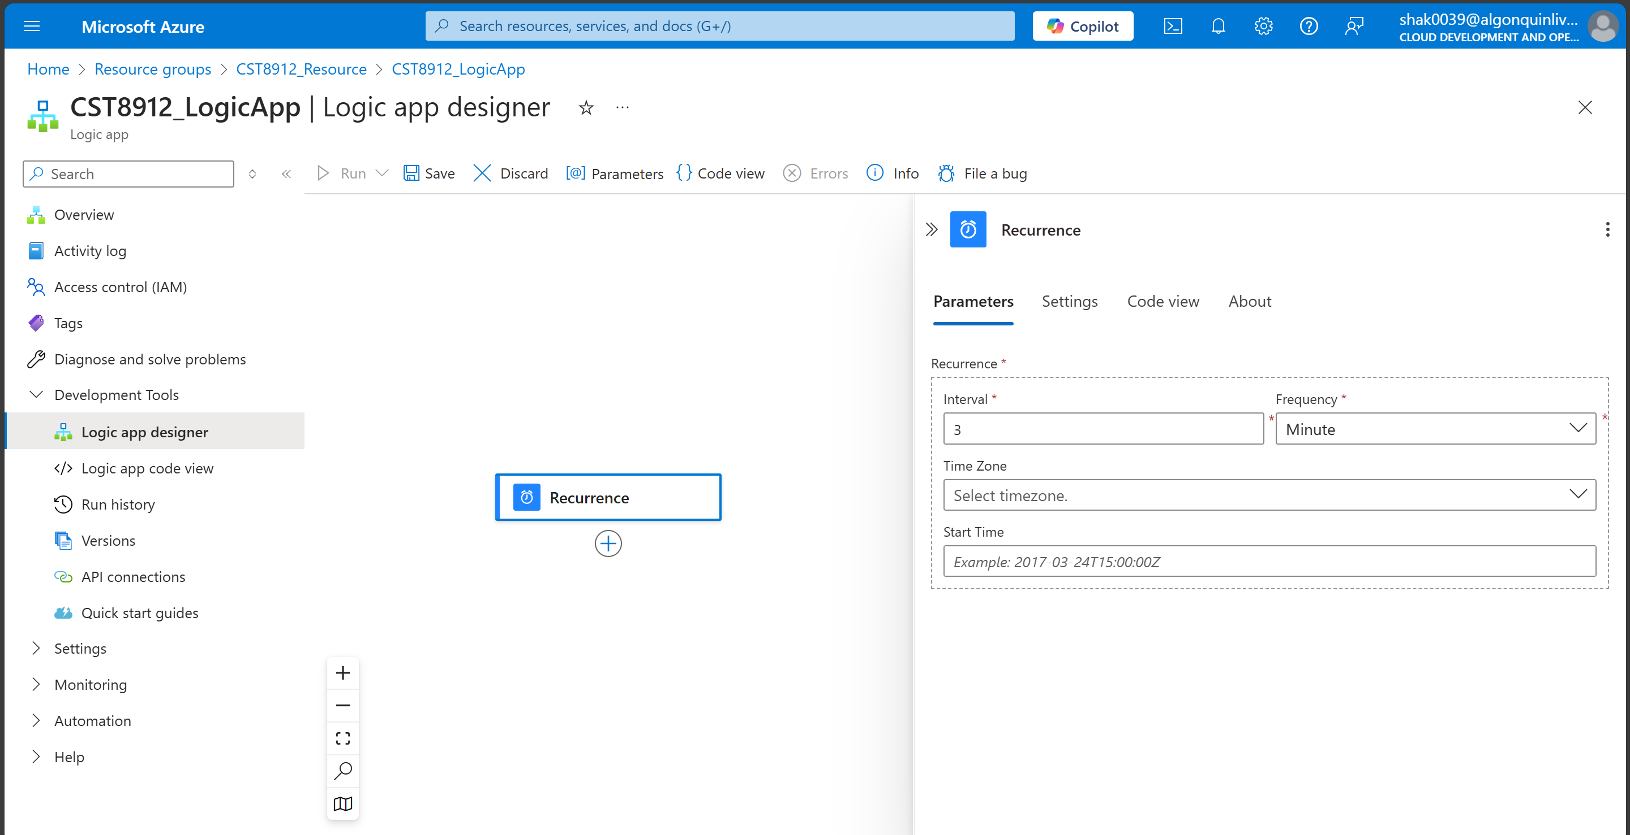

1. Add new step named “sql server” , use “get rows” as action.

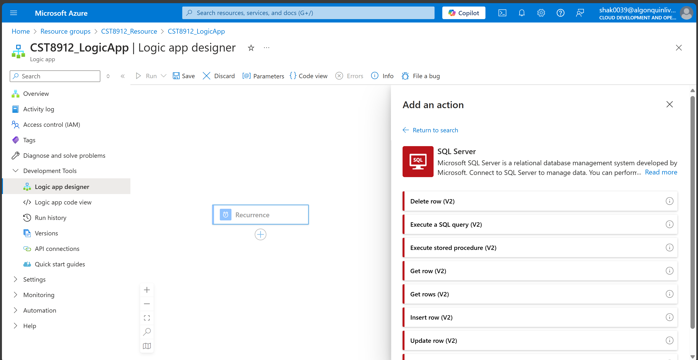

1. Enter the credentials (In background, connectors are getting created). Enter your server name (FQDN), database name, username and password.

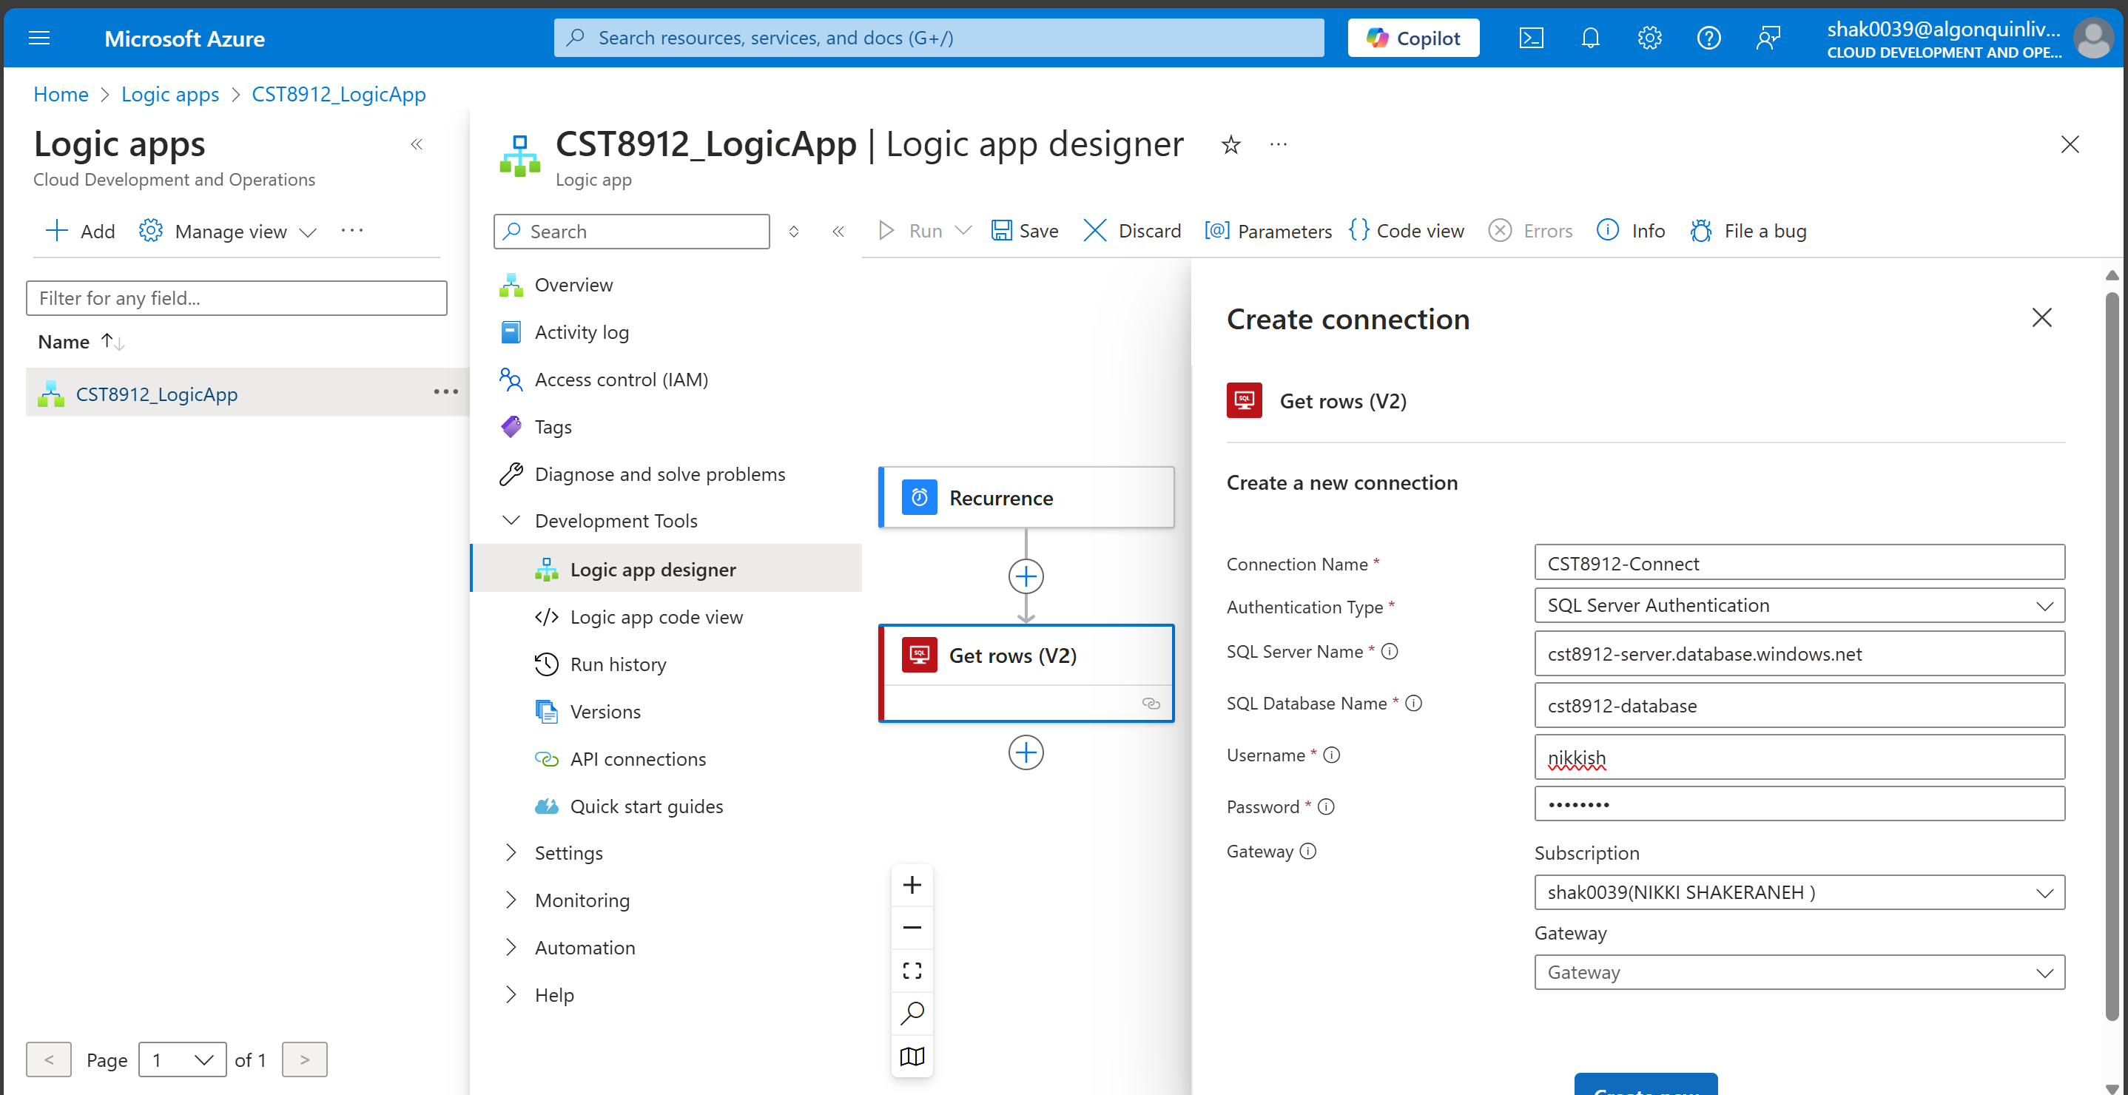

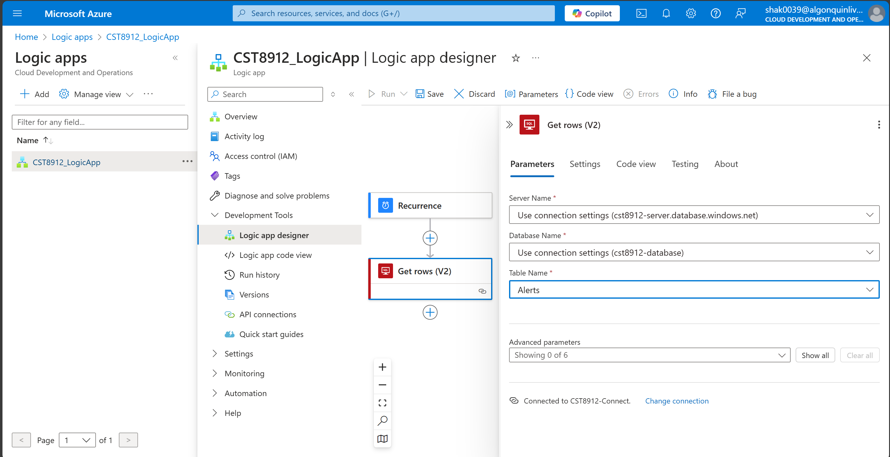

1. Add a new step ‘For-Each’ in the Logic App.
2. Select ‘Value’ Parameter from Dynamic Content

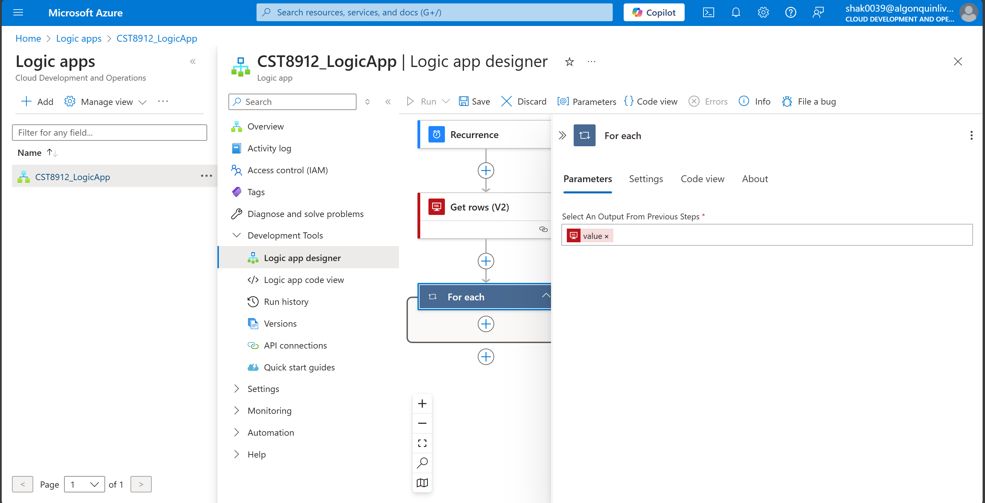

1. Now add a ‘Send mail’ Action.

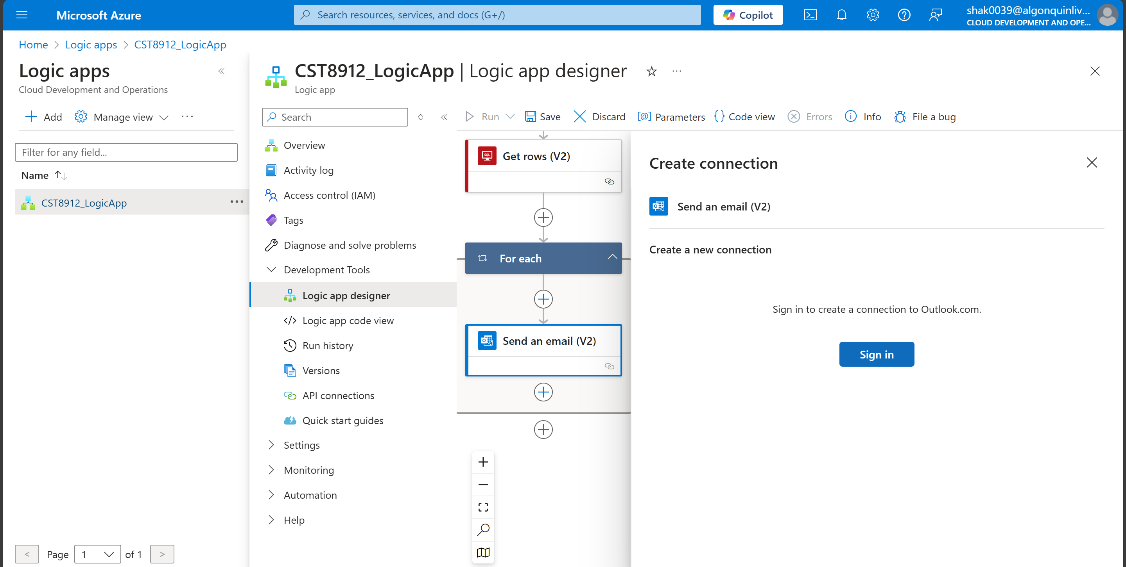

1. Enter the details from Dynamic content (refer to values from columns defined in the alerts table)

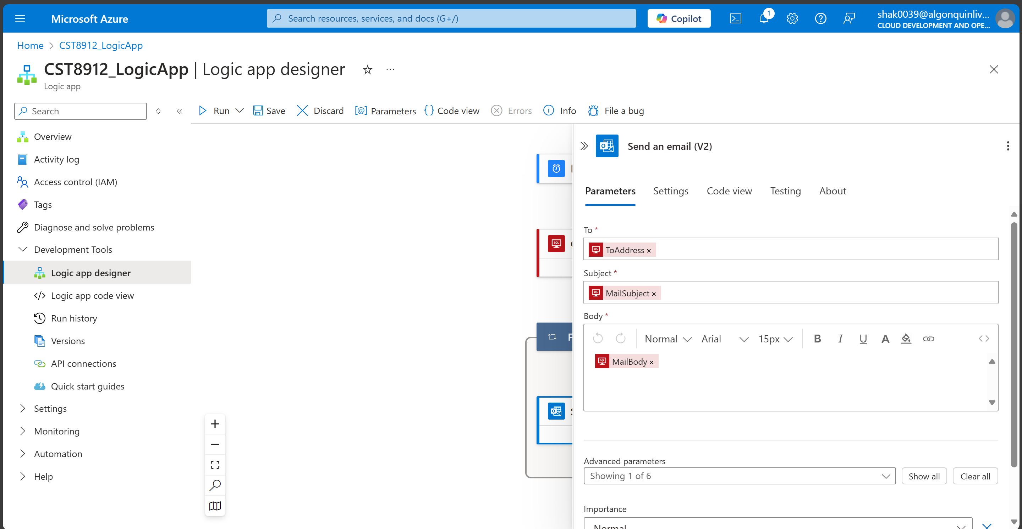

1. Save the Logic App.

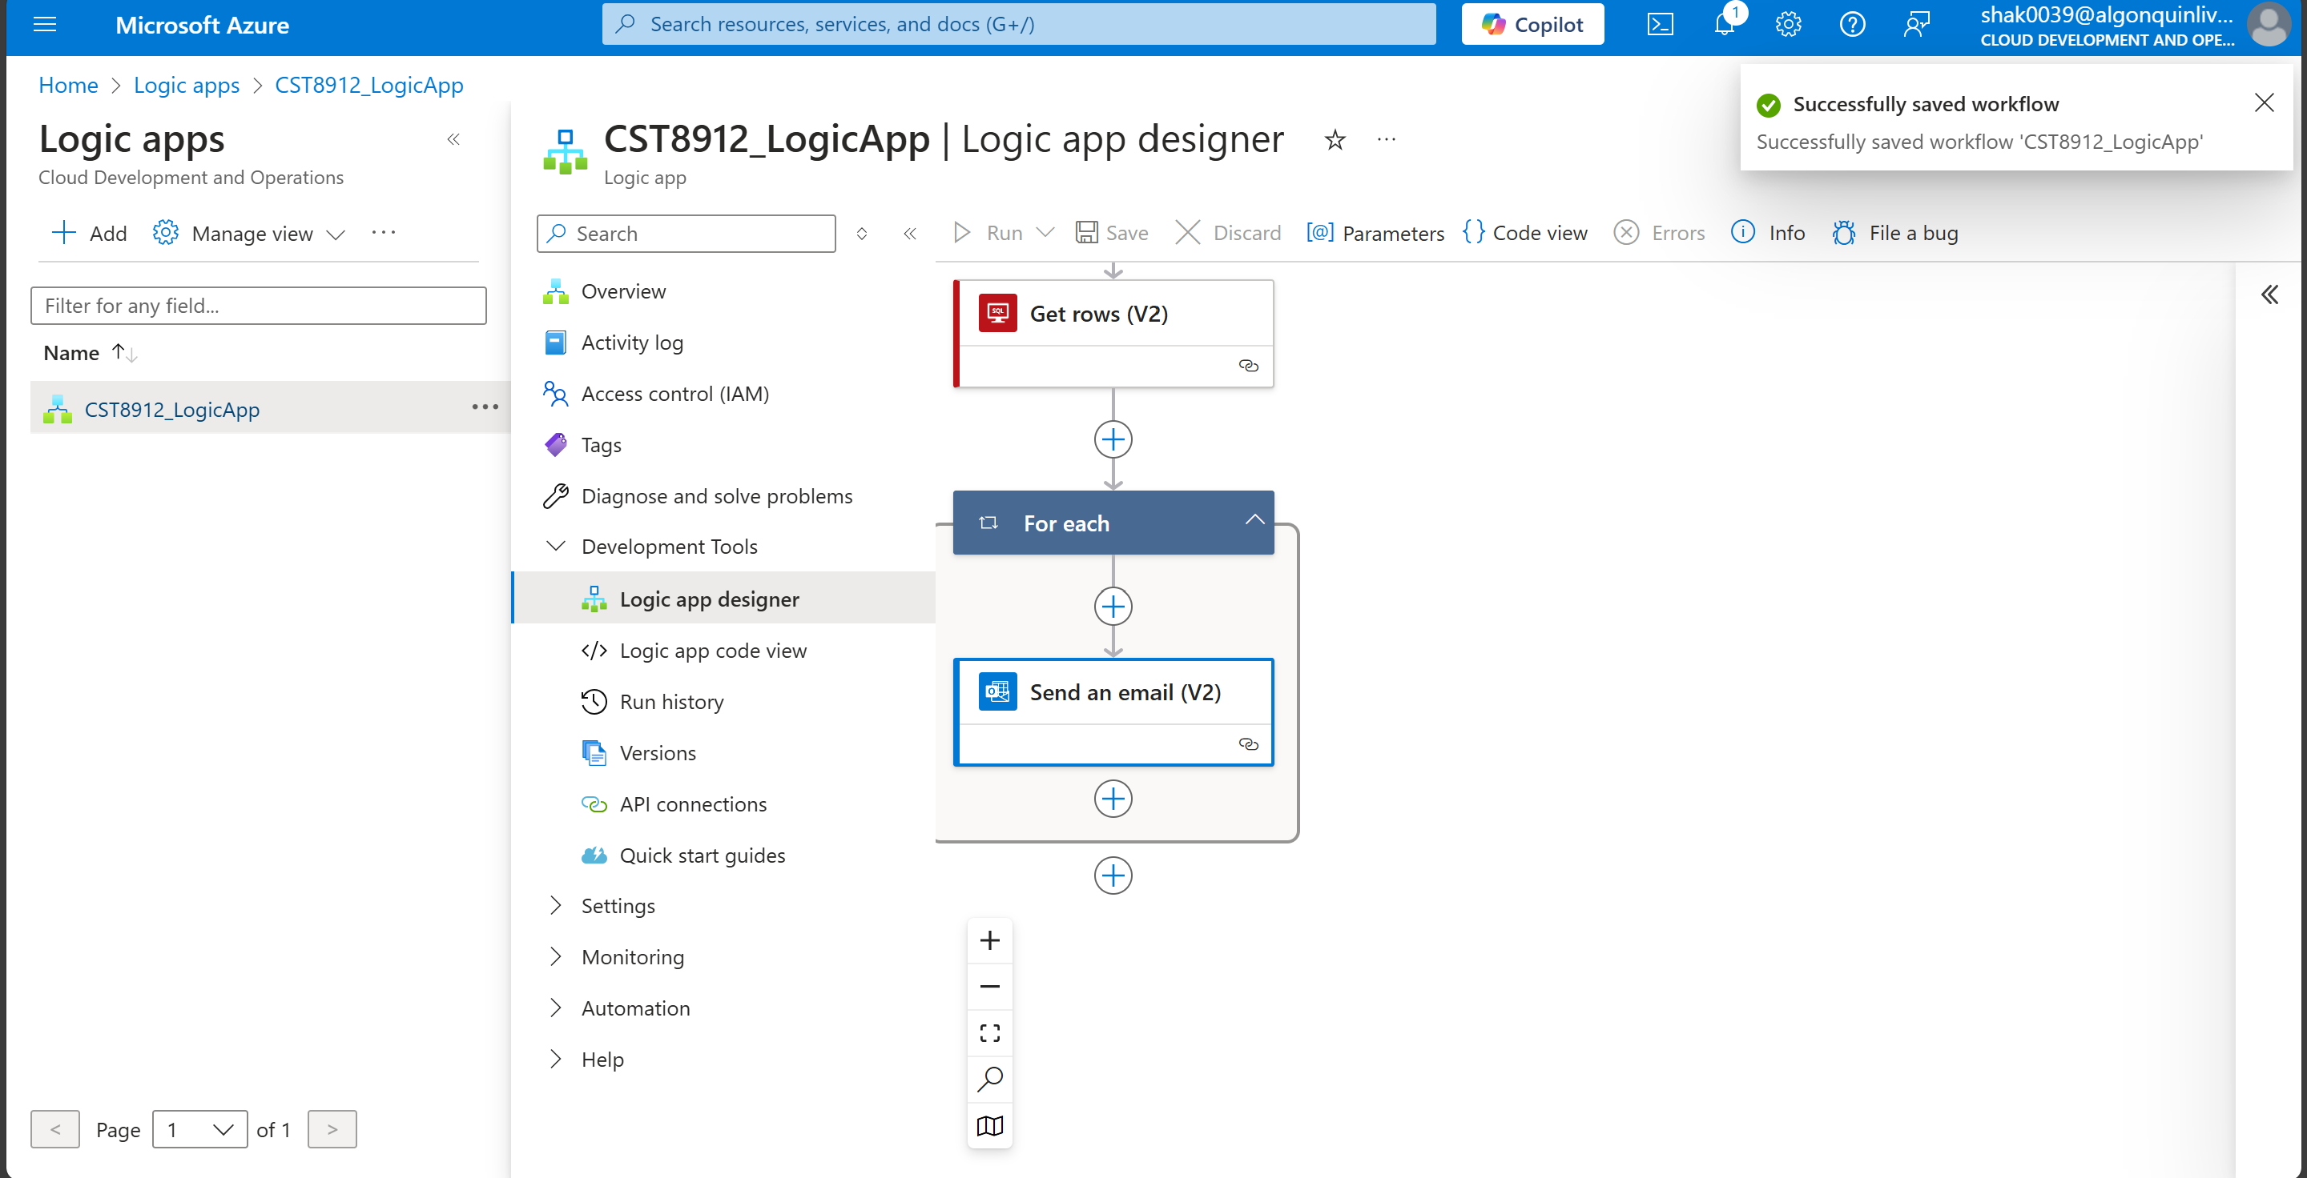

1. Wait for sometime and you will receive an email.

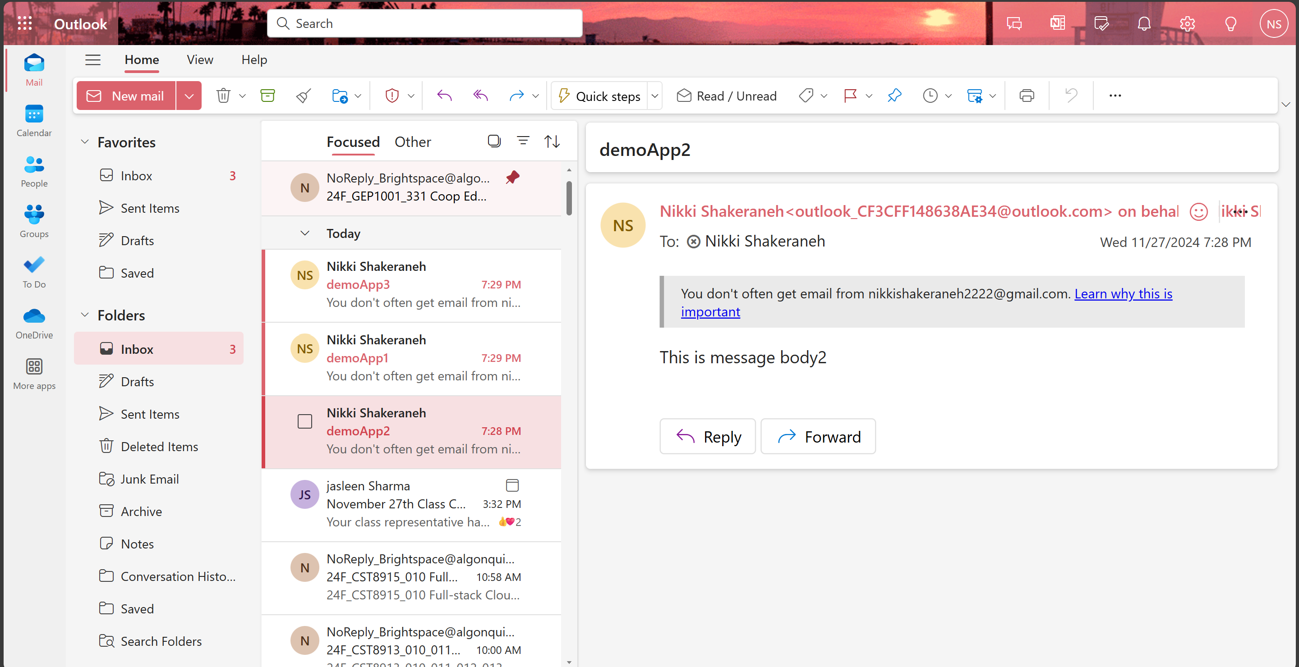

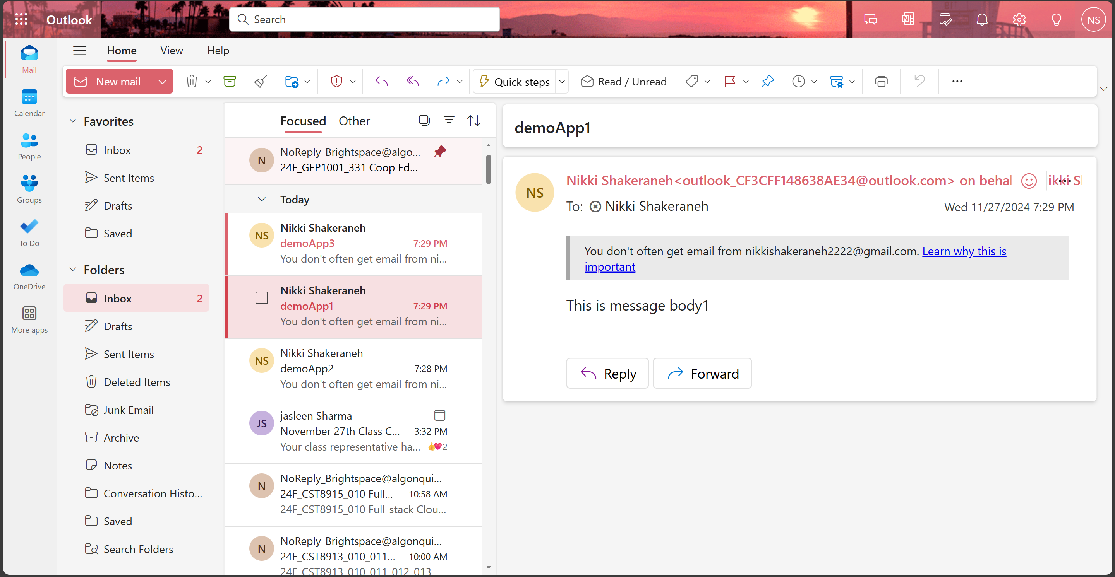

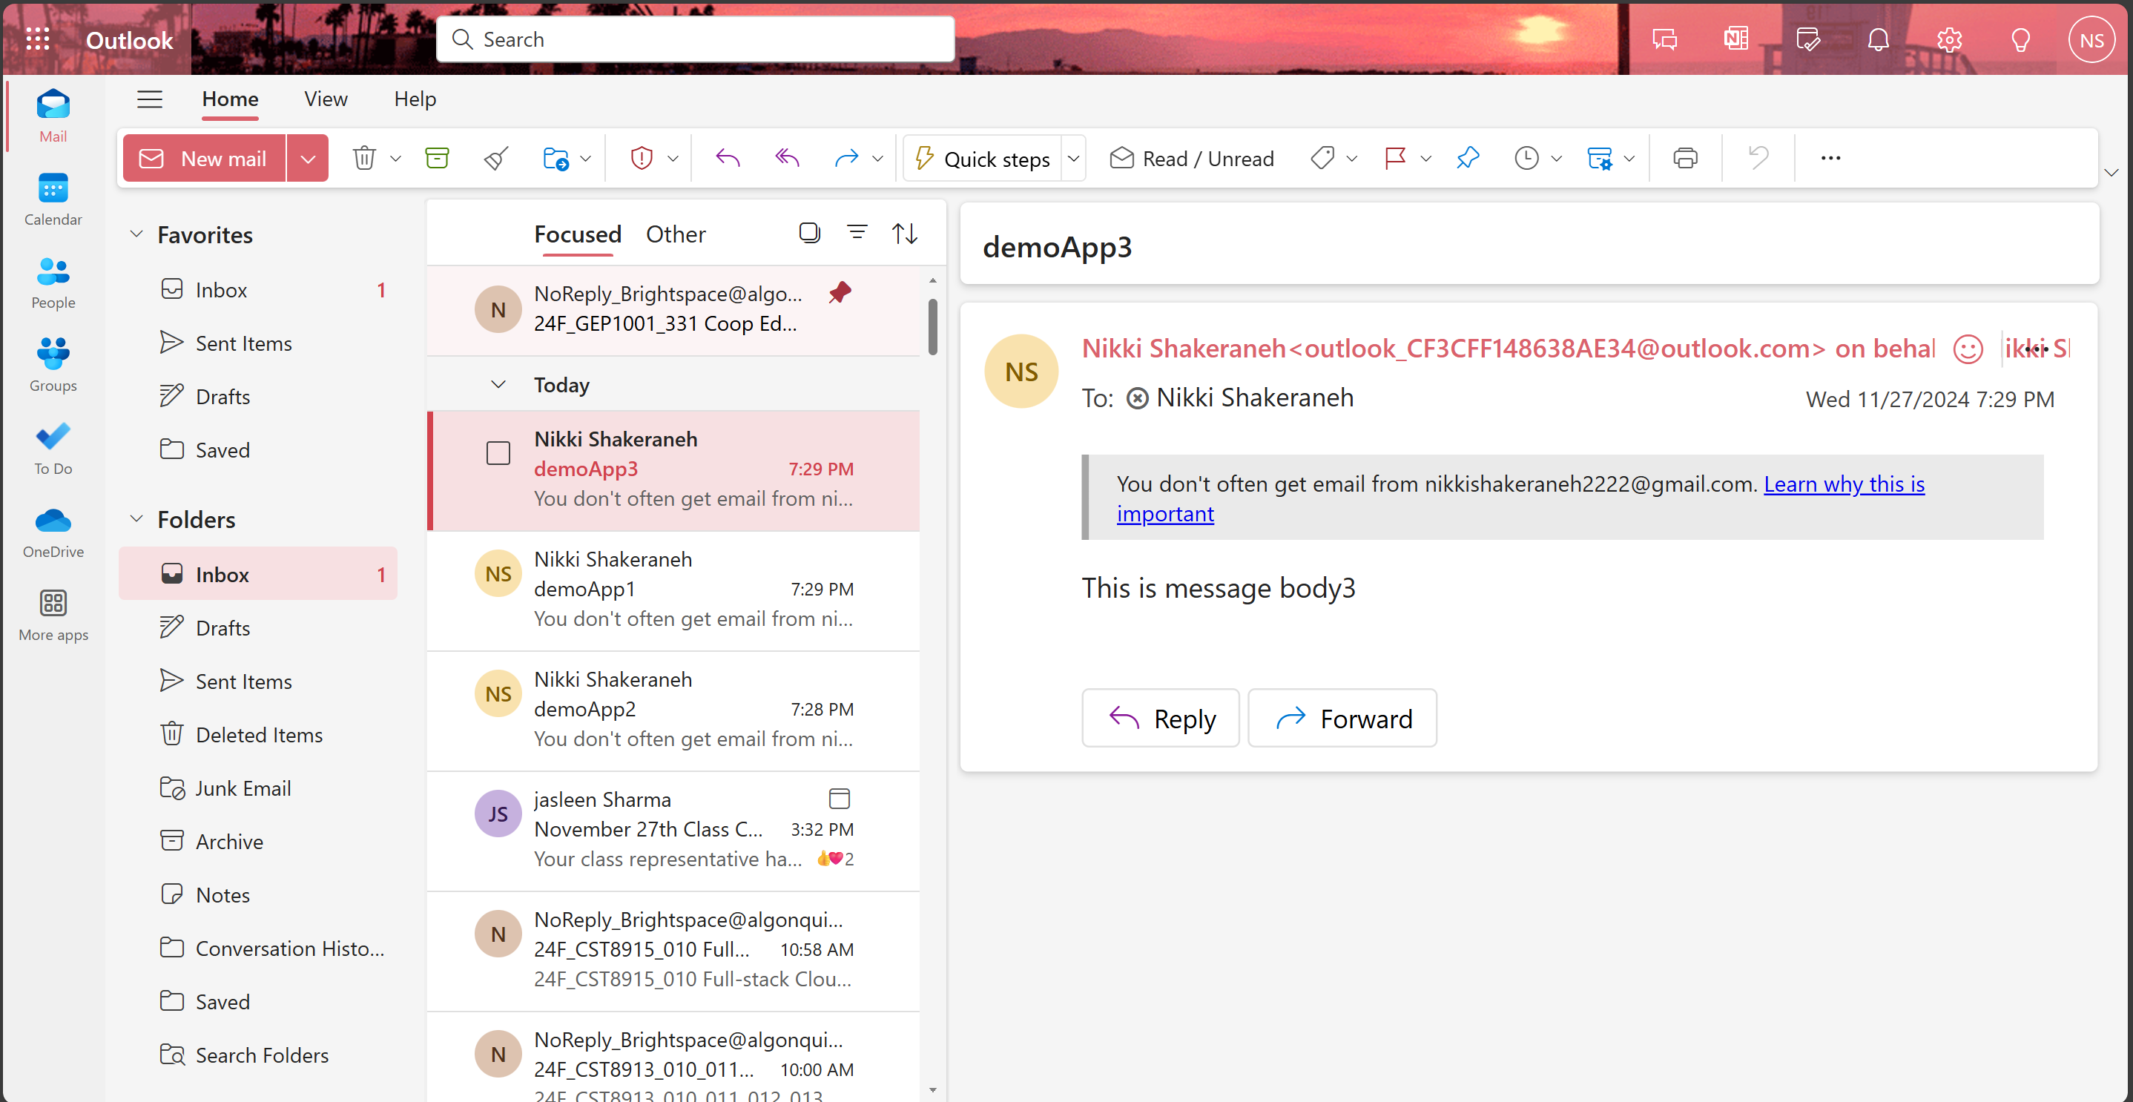

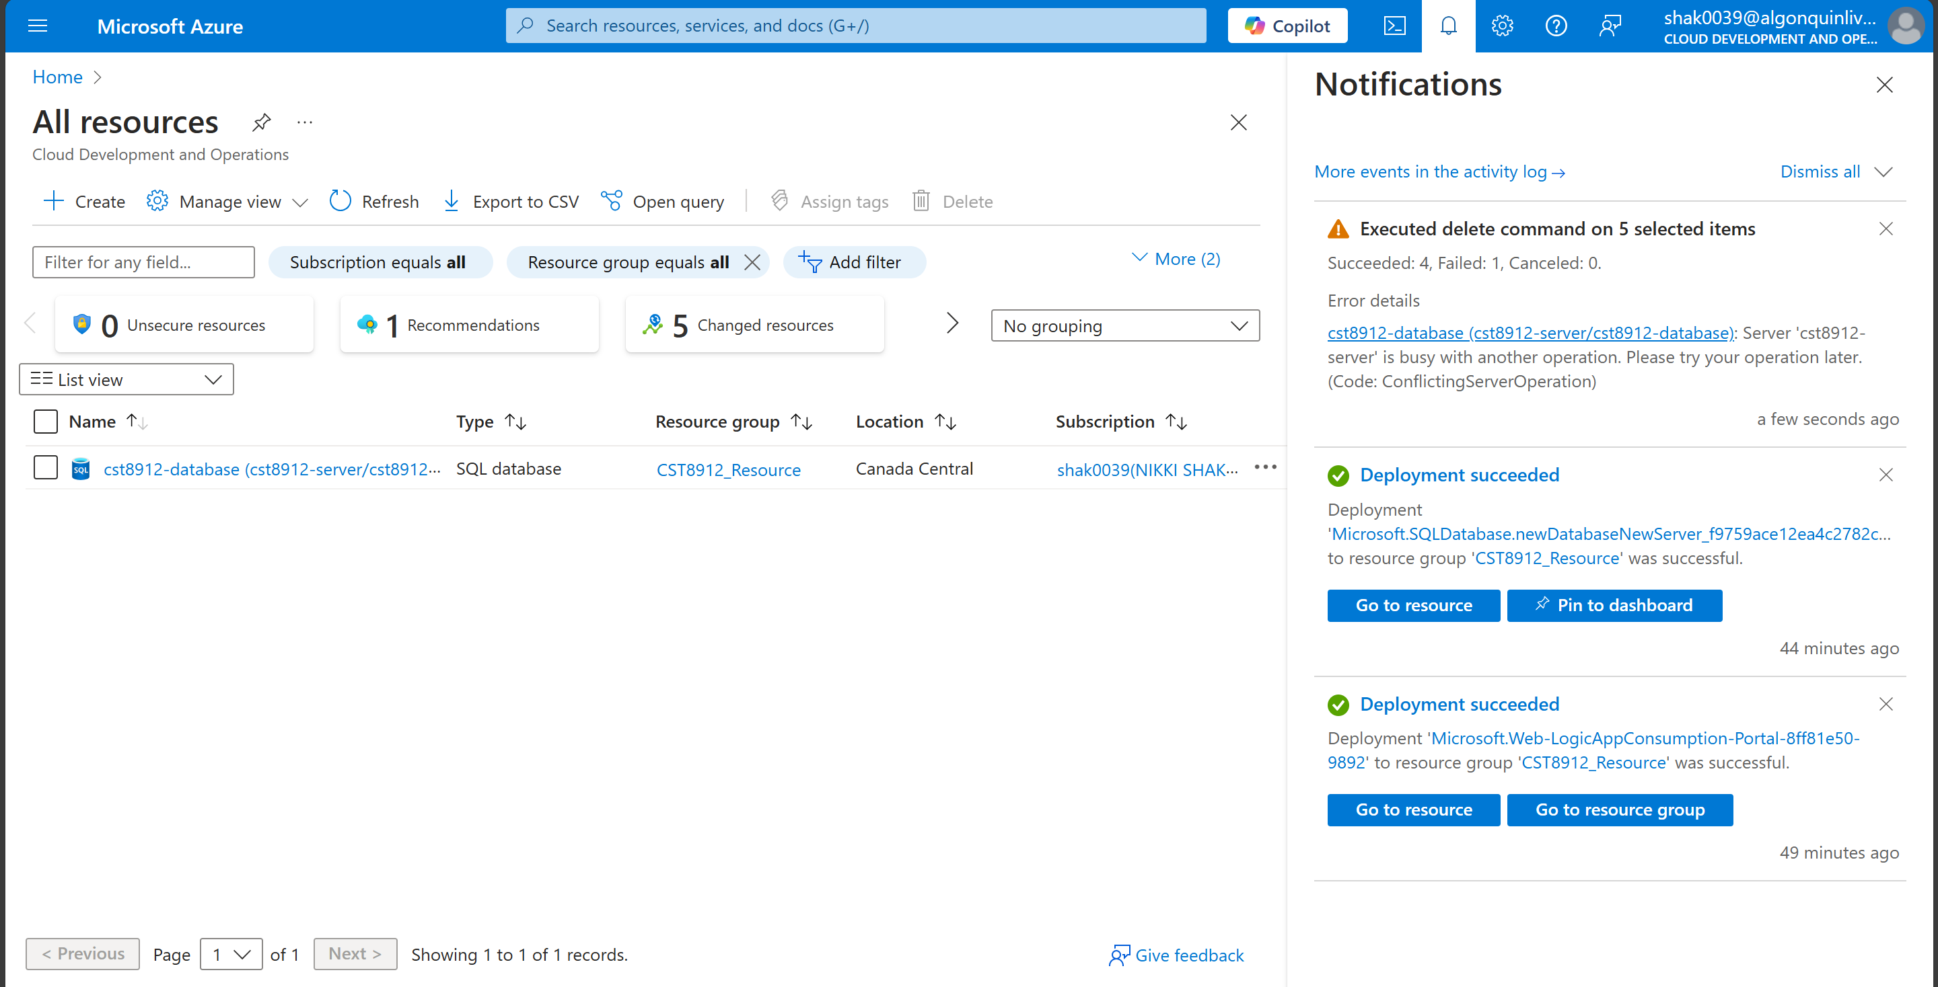

Task 2: Design a logic to trigger an email notification in your outlook when the file to a specific folder does not gets uploaded by specific time.

1. Create a storage account in Canada central region

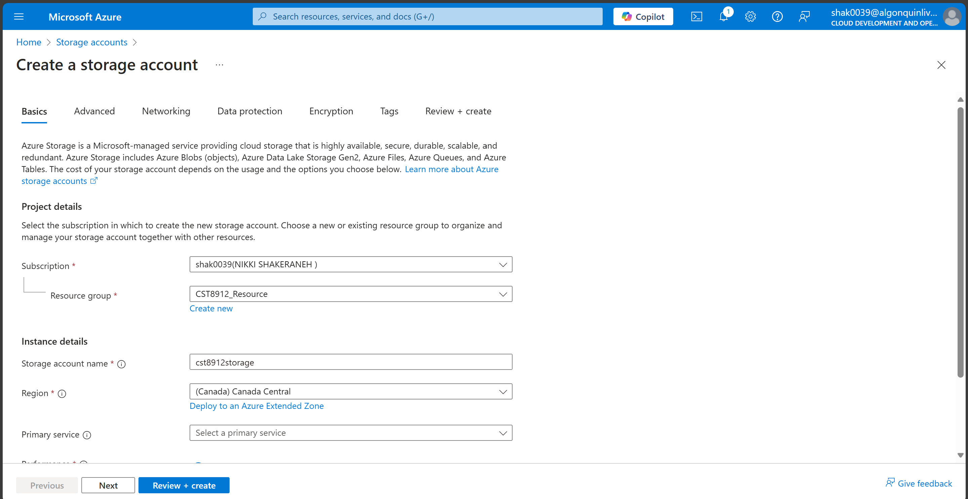

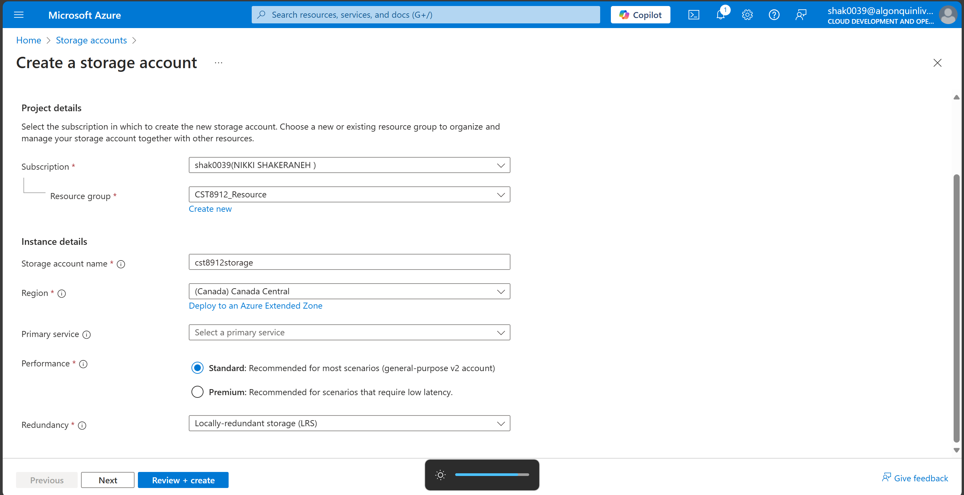

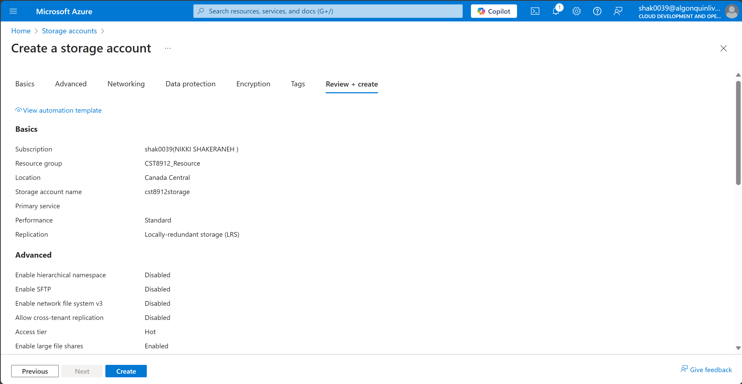

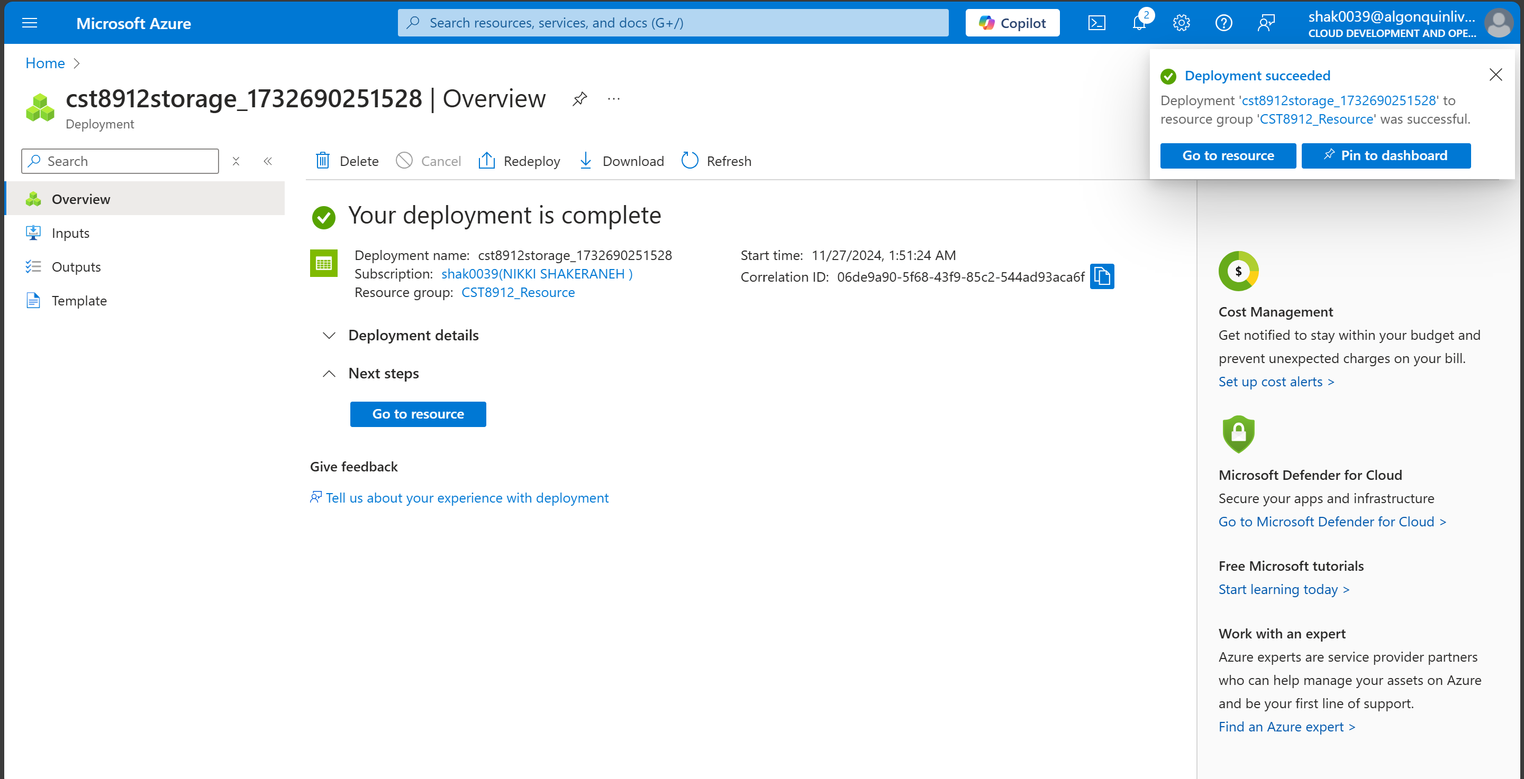

1. Create a sample container and within that container create folder in format of “yyyy-mm-dd”

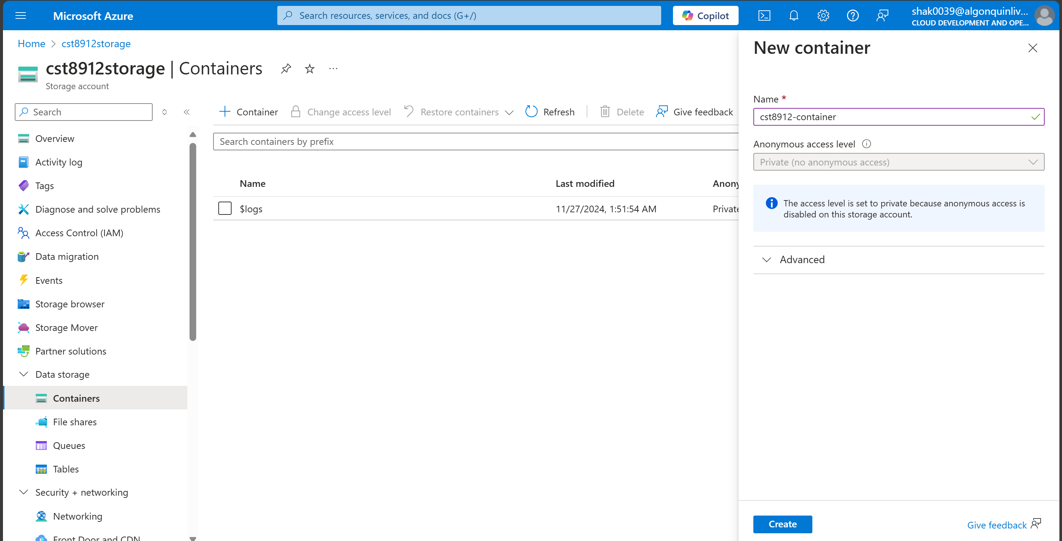

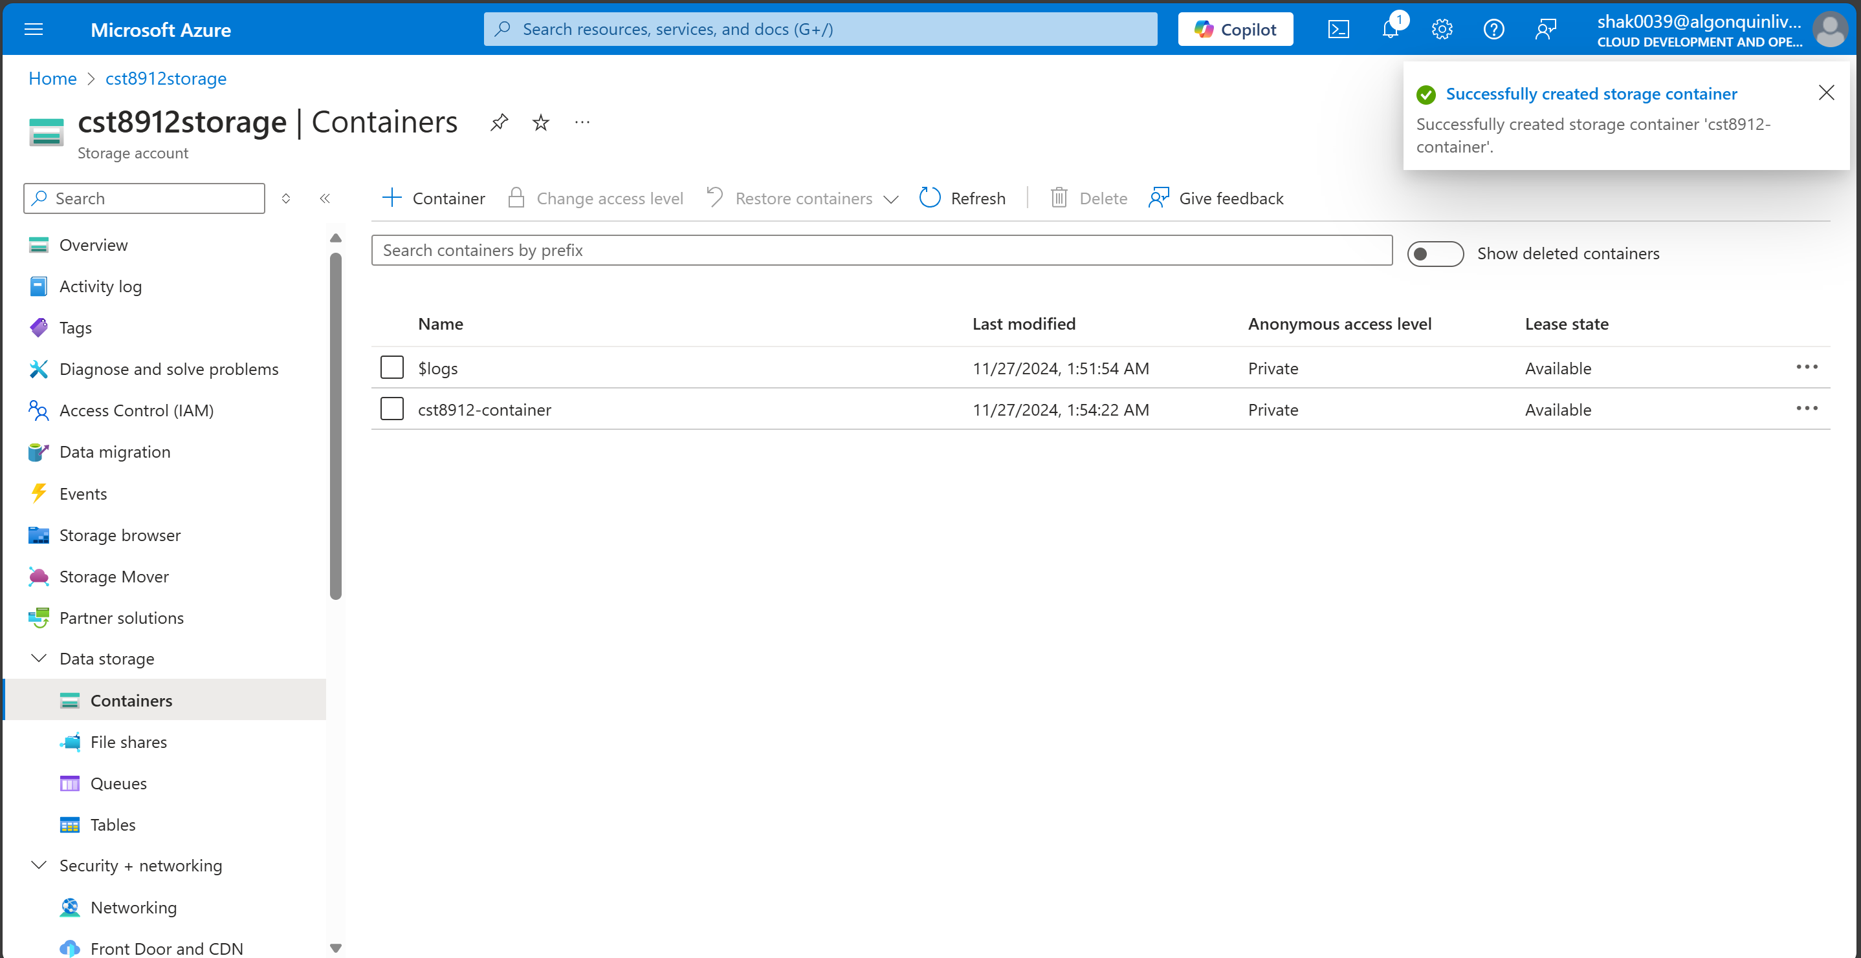

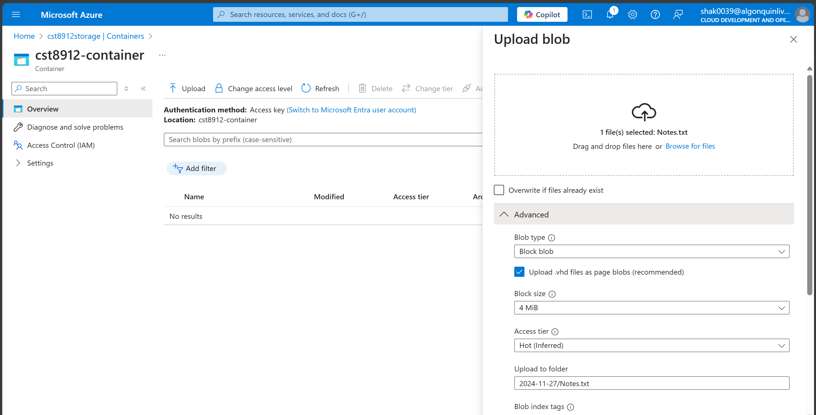

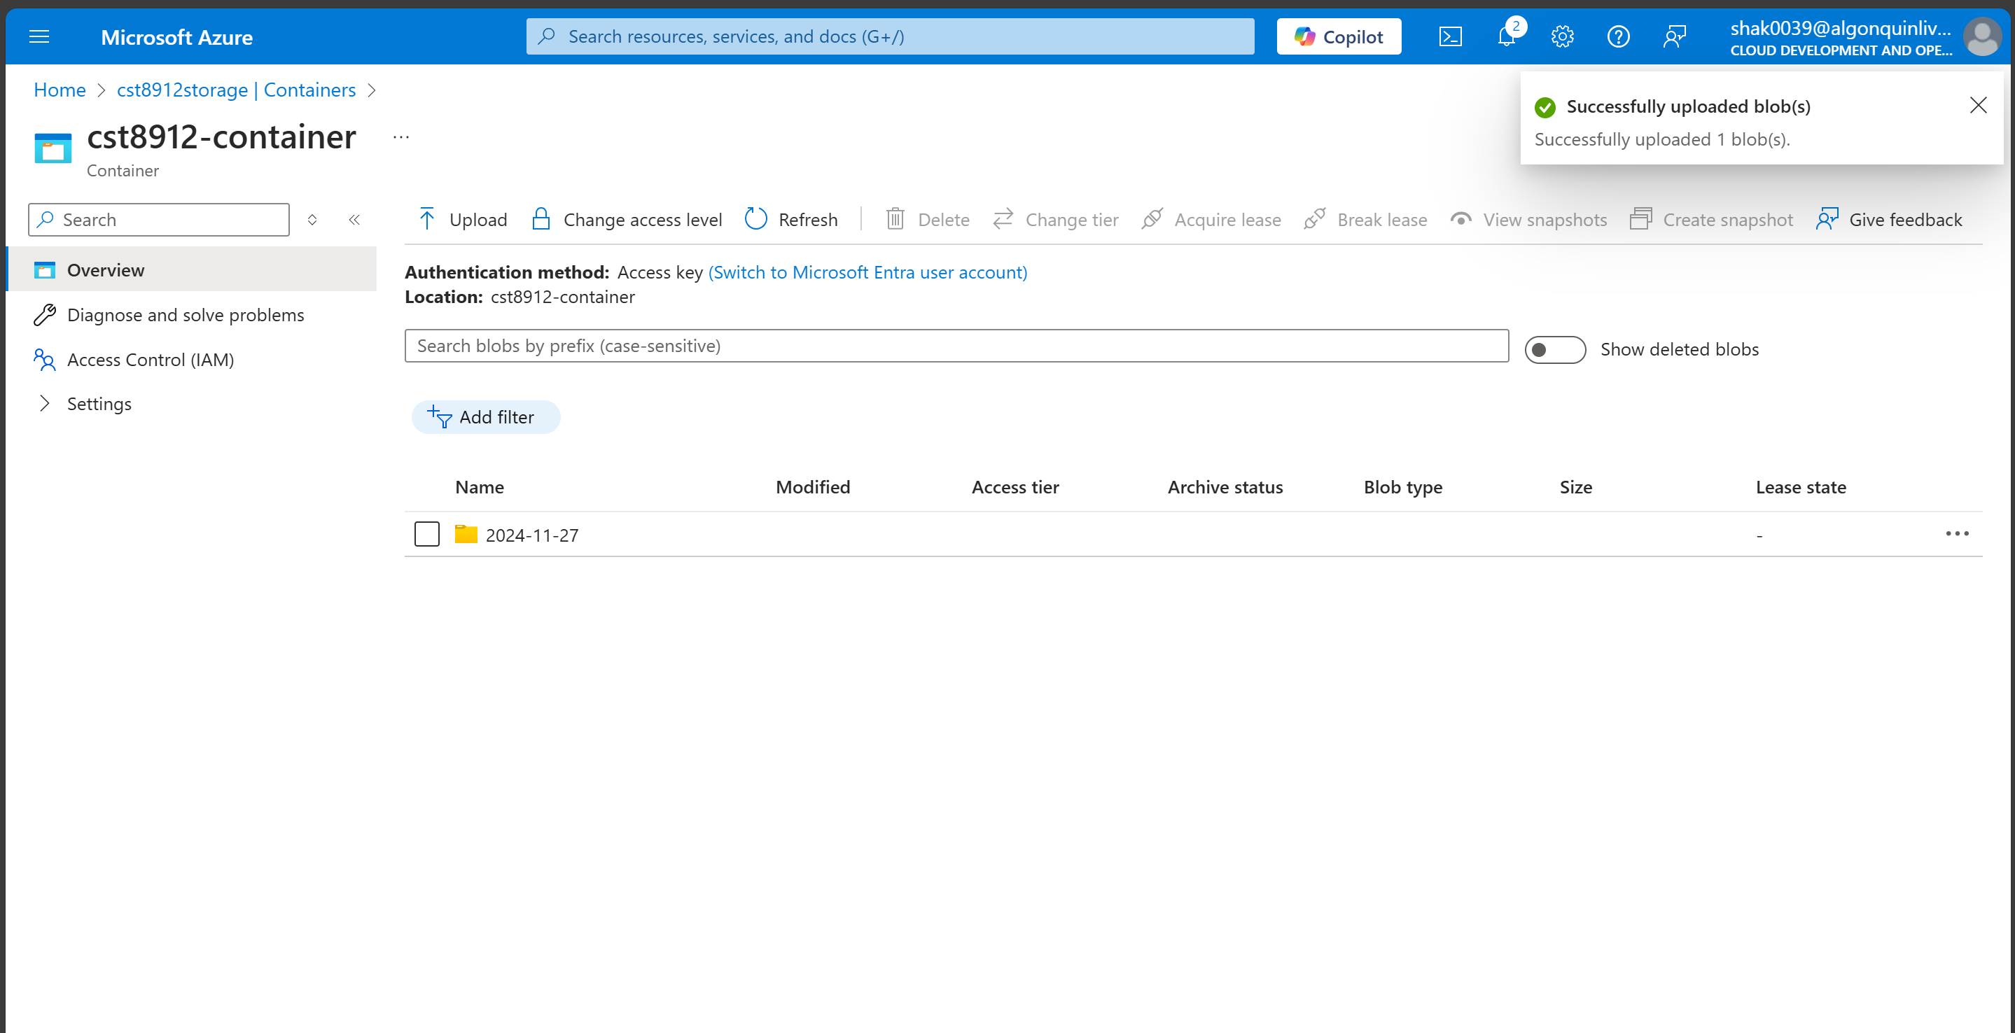

1. Create a trigger to schedule this logic everyday at 6pm

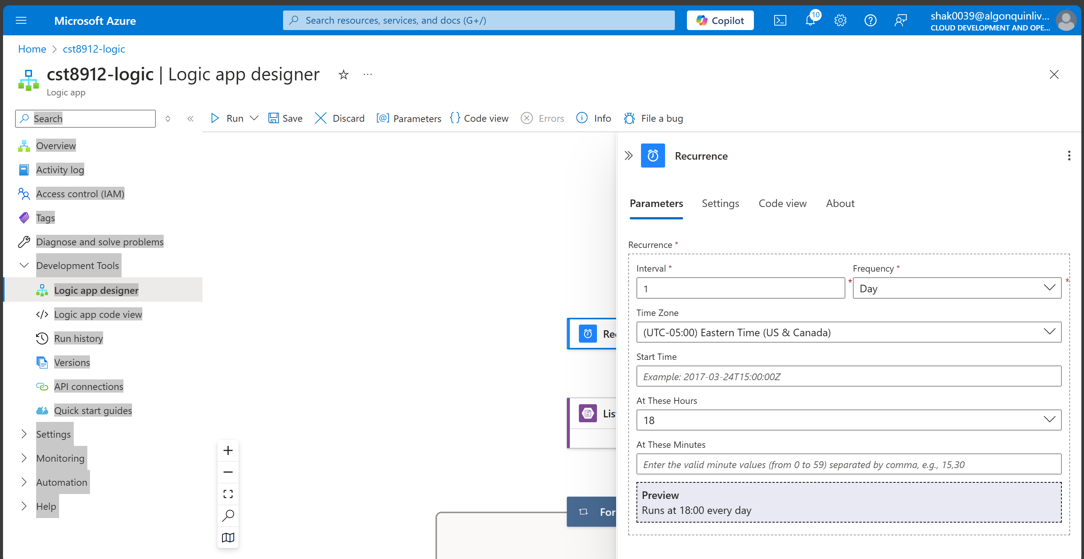

1. Use list blob to check every file in folder to check the file in the folder, you can use the expression like concat('/',utcNow('yyyy/MM/dd')), if the file in the path does not exists, list blob will fail.

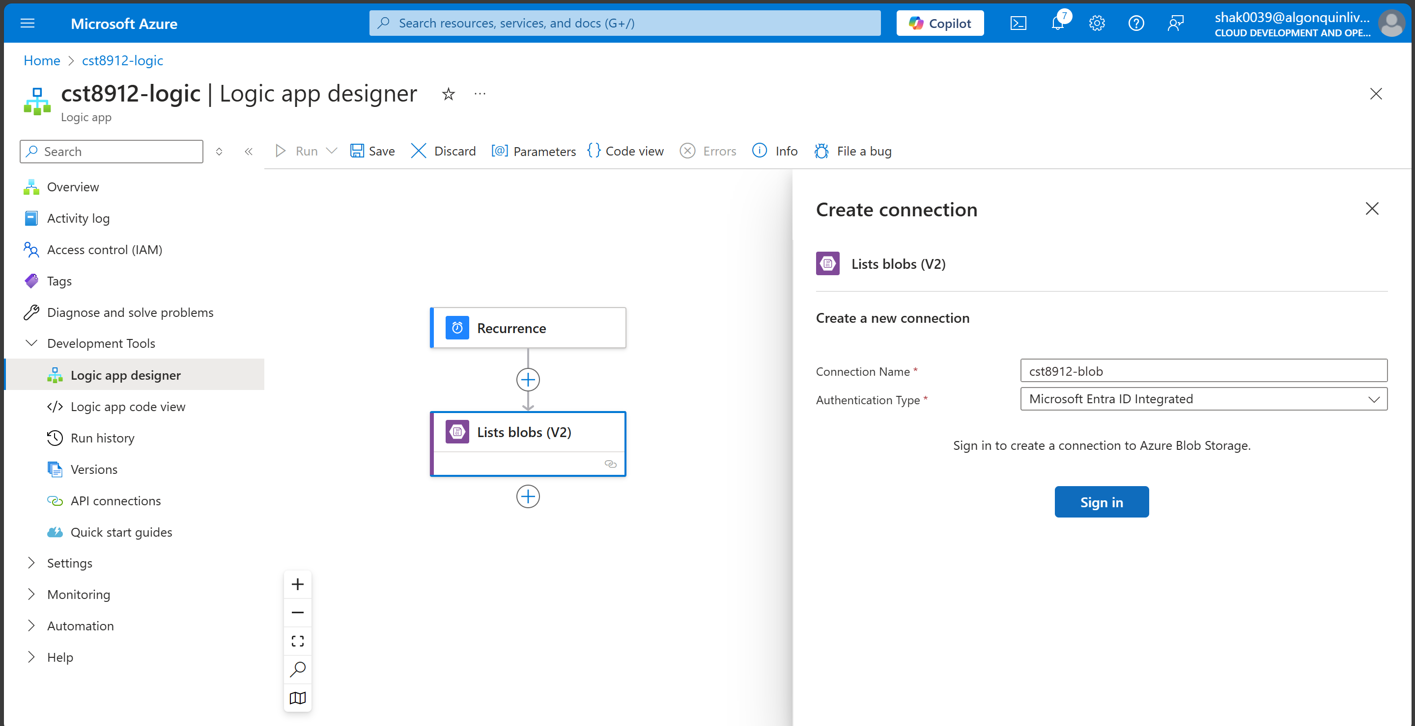

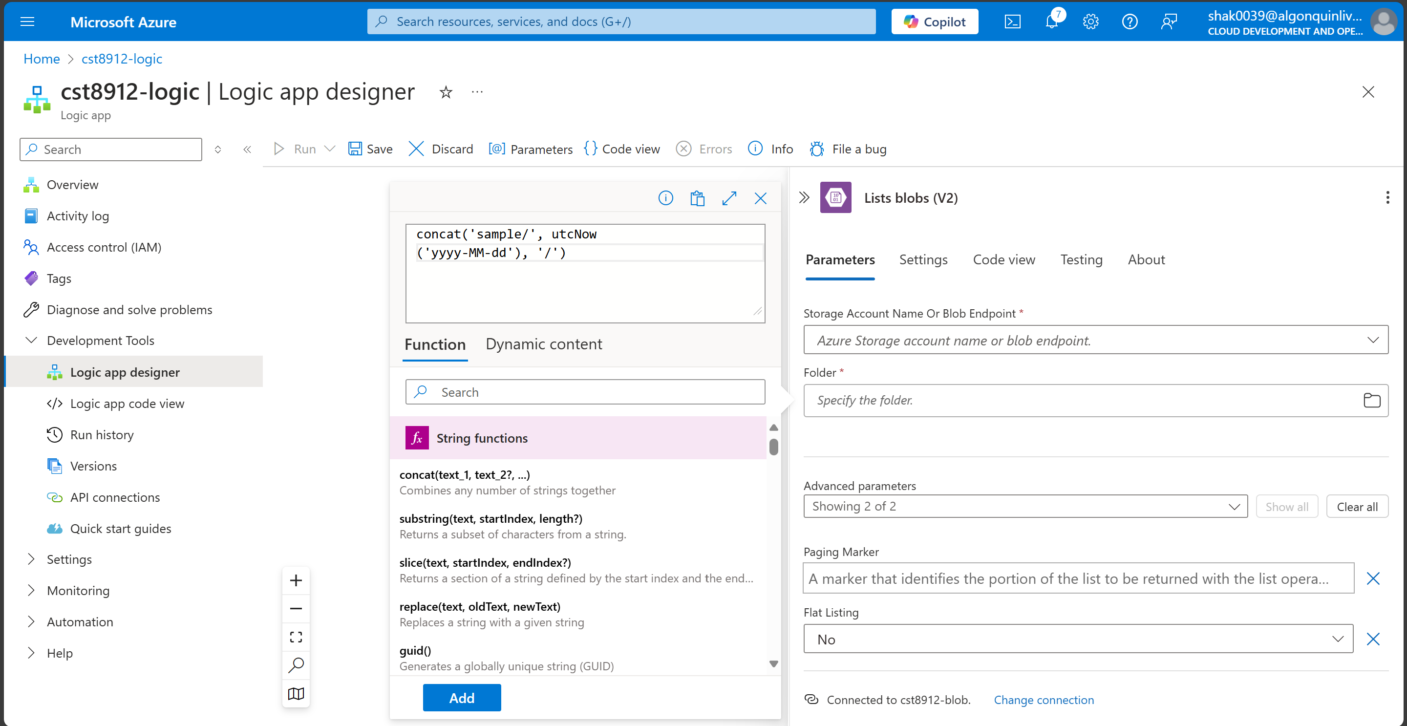

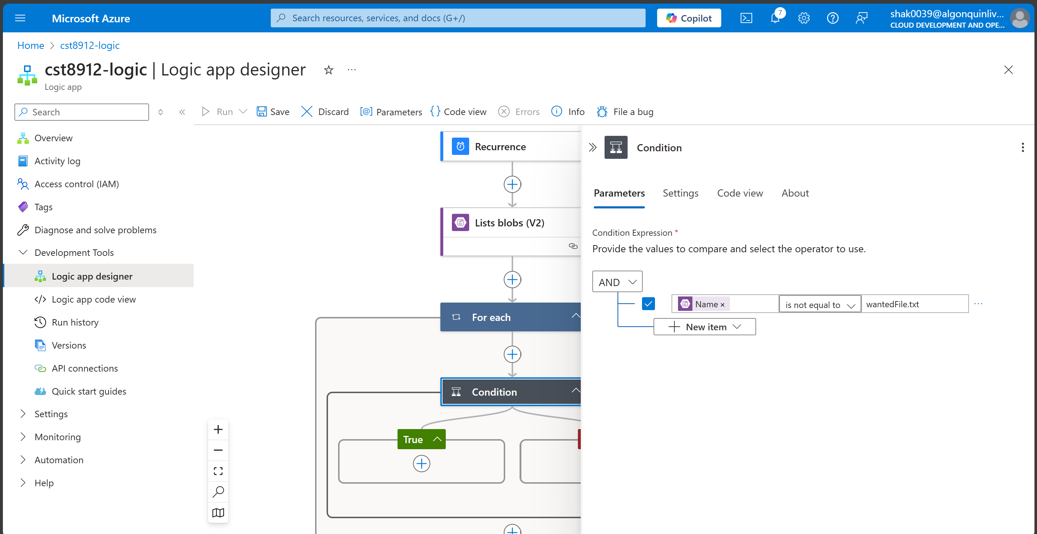

1. Send an email to your email address in outlook if list blob fails.

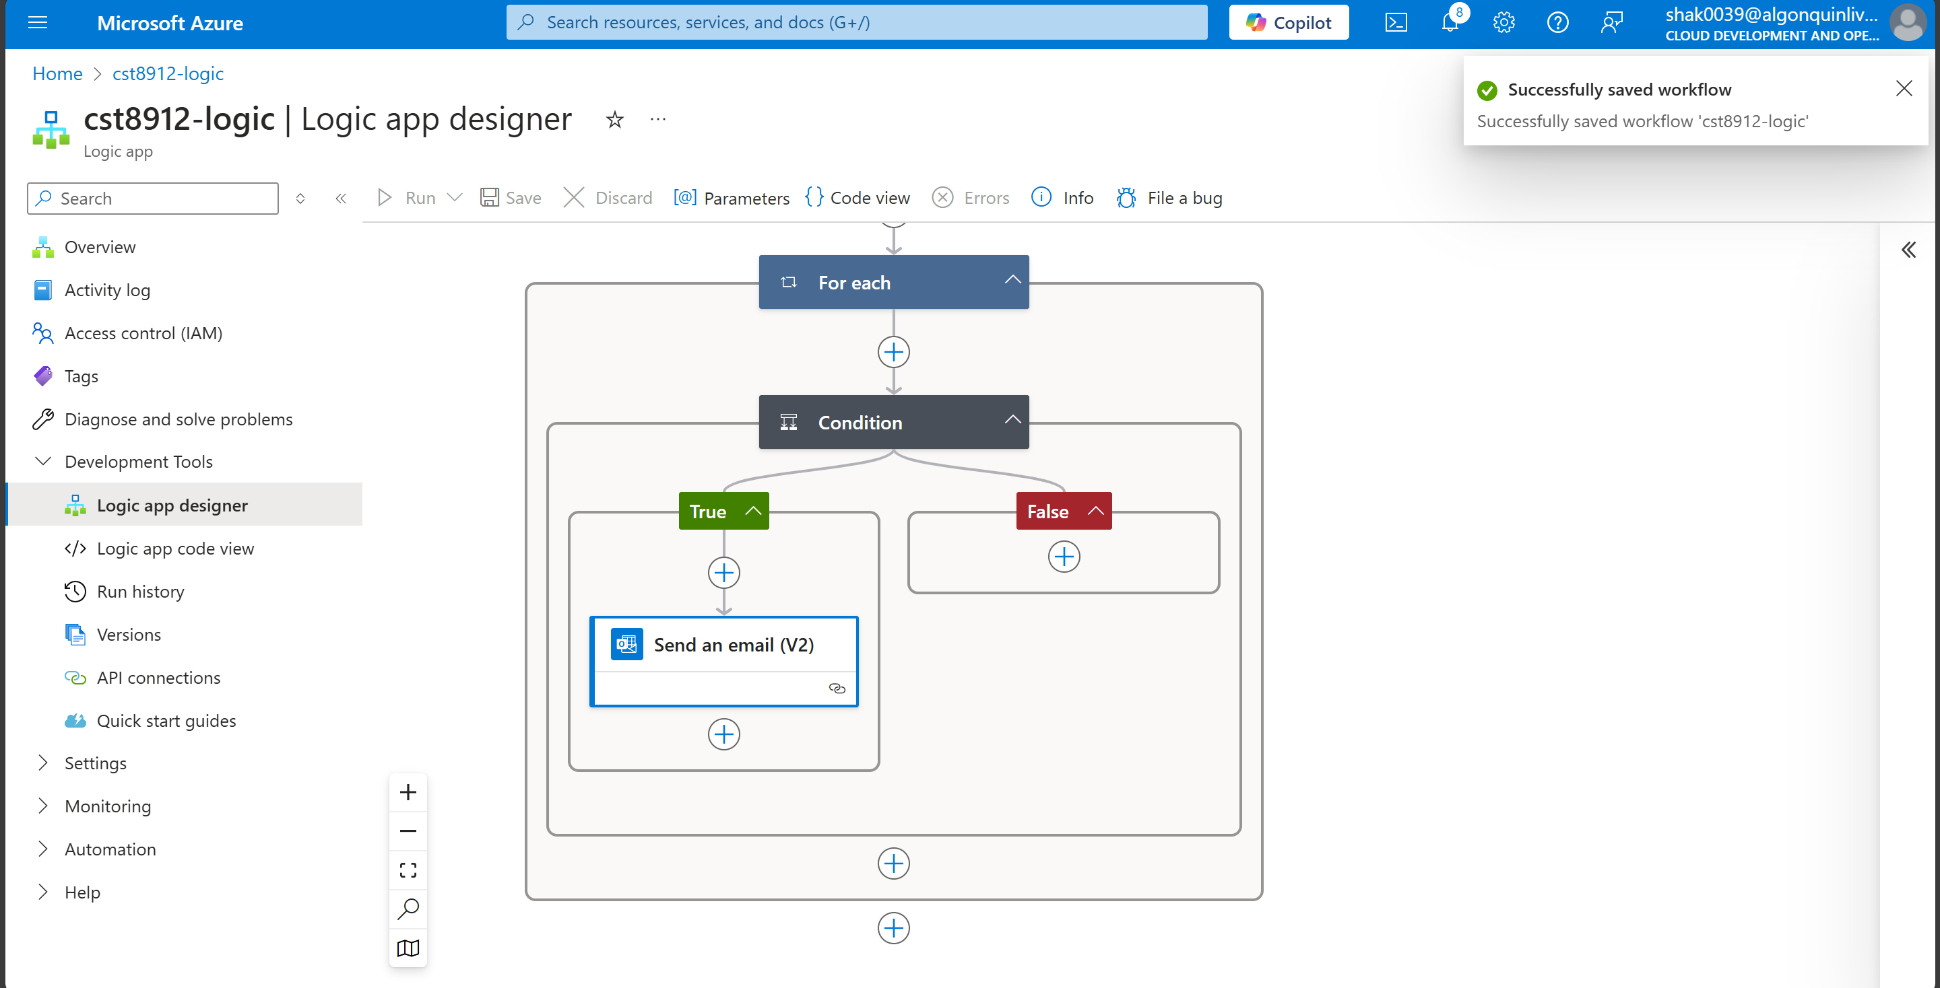

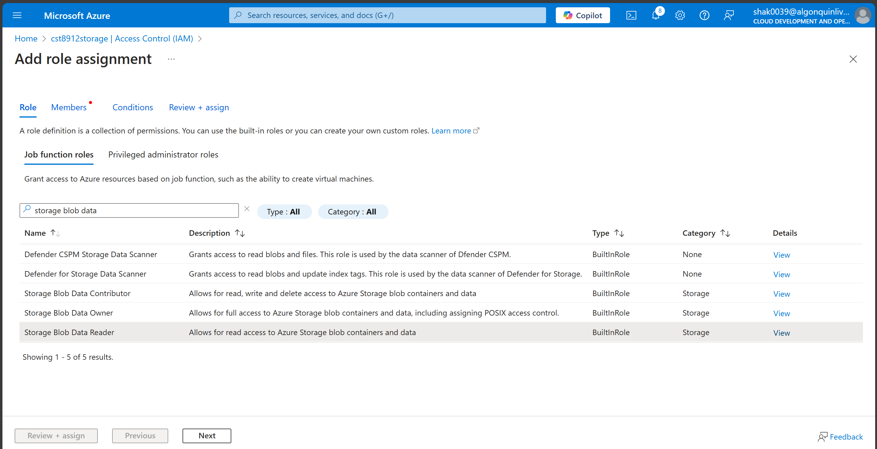

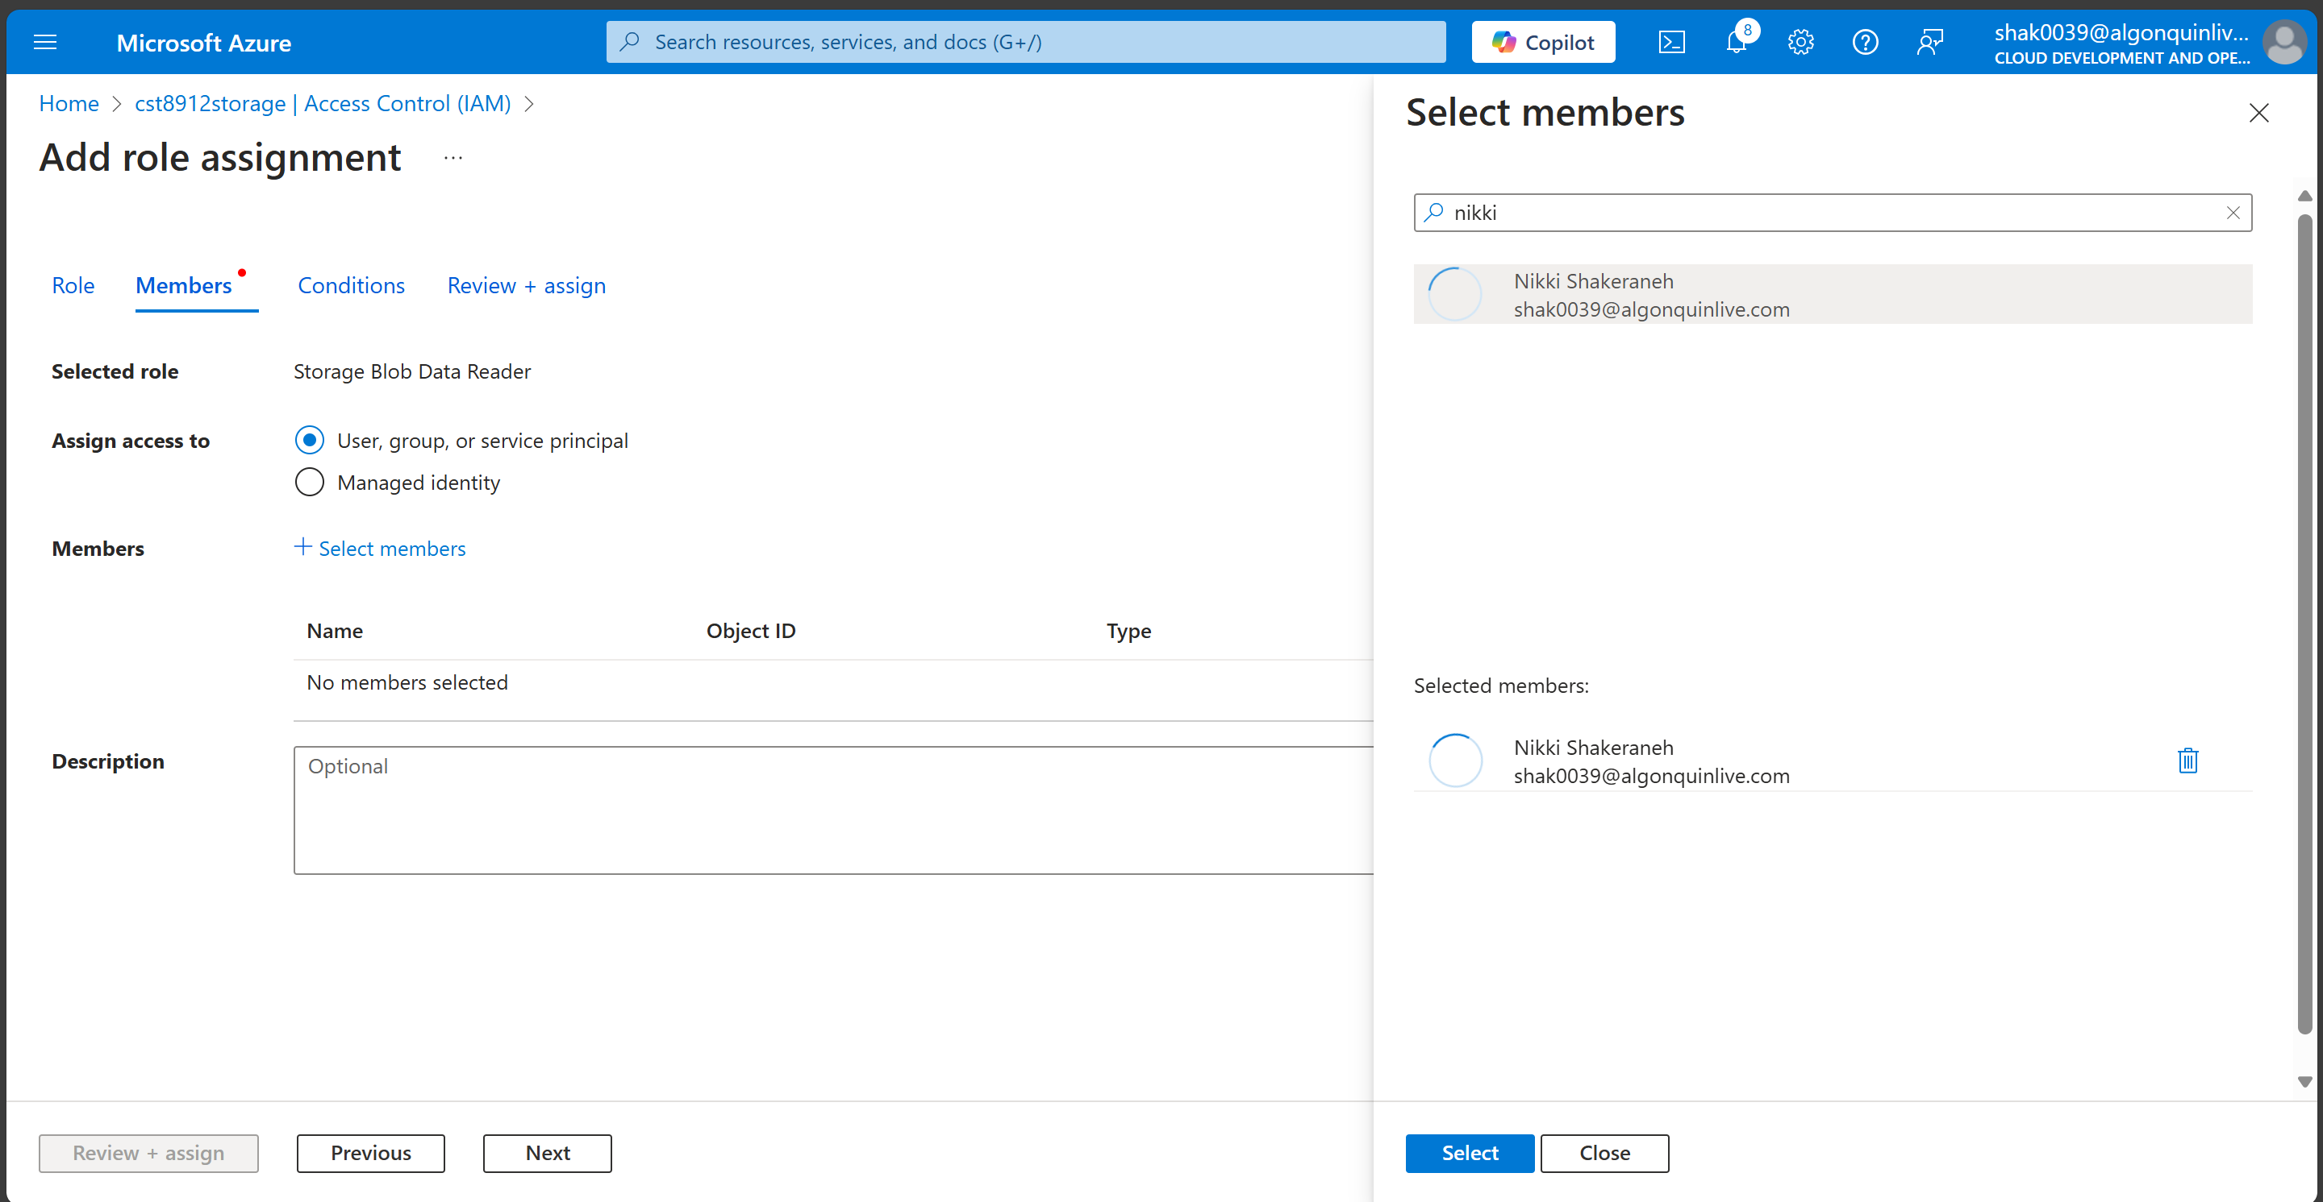

Task 3: Monitor workflows in azure logic apps

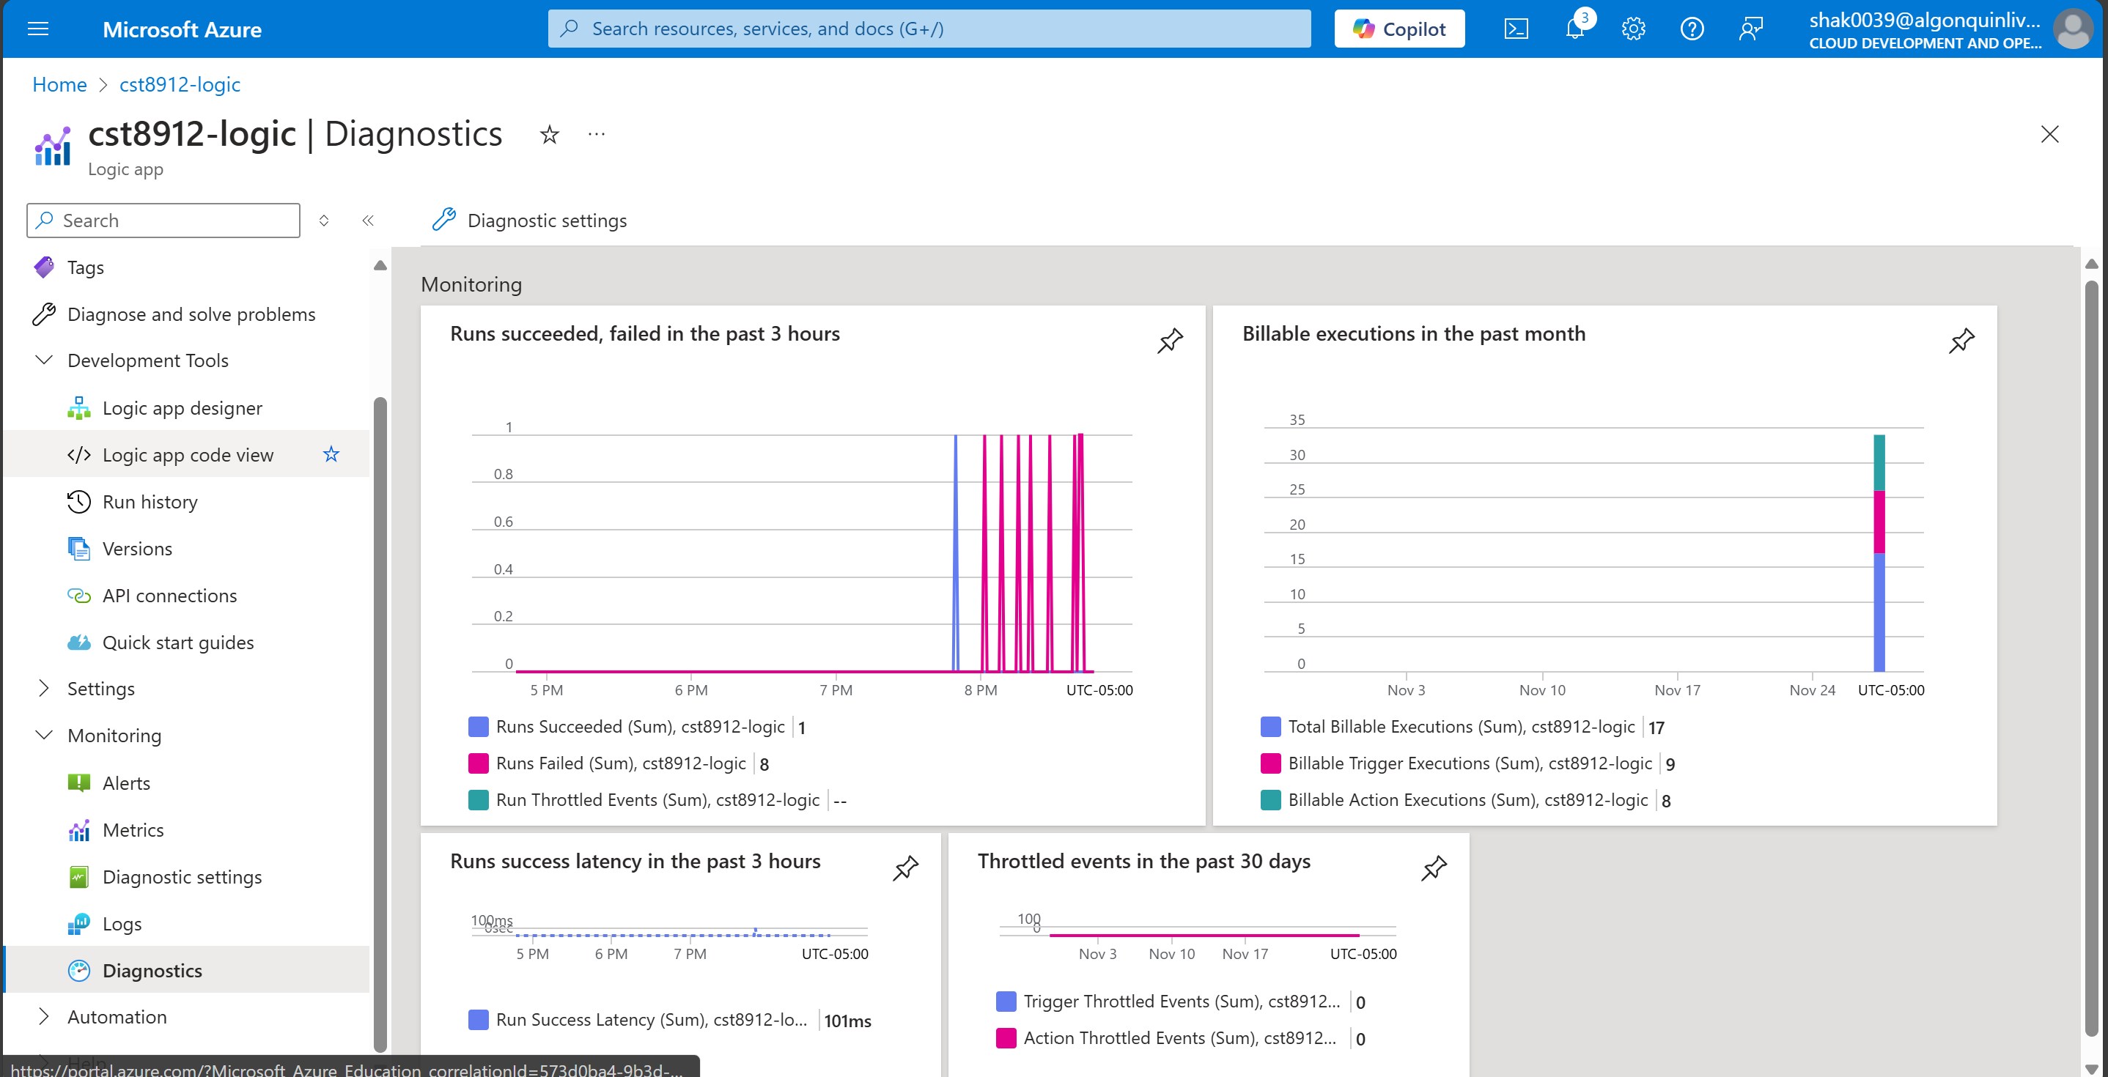

Task4: Clean all the resources created during this lab and record all the steps with screenshots in the lab report.

